ТЕСТ НА ПЕРЕВІРКУ РОБОТИ КОДІВ OpenCV

**1)Basic Drawing**

import cv2 as cv  
import numpy as np  
W = 400  
def my_ellipse(img, angle):  
 thickness = 2  
 line_type = 8  
 cv.ellipse(img,  
 (W // 2, W // 2),  
 (W // 4, W // 16),  
 angle,  
 0,  
 360,  
 (255, 0, 0),  
 thickness,  
 line_type)  
def my_filled_circle(img, center):  
 thickness = -1  
 line_type = 8  
 cv.circle(img,  
 center,  
 W // 32,  
 (0, 0, 255),  
 thickness,  
 line_type)  
def my_polygon(img):  
 line_type = 8  
 # Create some points  
 ppt = np.array([[W / 4, 7 * W / 8], [3 * W / 4, 7 * W / 8],  
 [3 * W / 4, 13 * W / 16], [11 * W / 16, 13 * W / 16],  
 [19 * W / 32, 3 * W / 8], [3 * W / 4, 3 * W / 8],  
 [3 * W / 4, W / 8], [26 * W / 40, W / 8],  
 [26 * W / 40, W / 4], [22 * W / 40, W / 4],  
 [22 * W / 40, W / 8], [18 * W / 40, W / 8],  
 [18 * W / 40, W / 4], [14 * W / 40, W / 4],  
 [14 * W / 40, W / 8], [W / 4, W / 8],  
 [W / 4, 3 * W / 8], [13 * W / 32, 3 * W / 8],  
 [5 * W / 16, 13 * W / 16], [W / 4, 13 * W / 16]], np.int32)  
 ppt = ppt.reshape((-1, 1, 2))  
 cv.fillPoly(img, [ppt], (255, 255, 255), line_type)  
 # Only drawind the lines would be:  
 # cv.polylines(img, [ppt], True, (255, 0, 255), line_type)  
def my_line(img, start, end):  
 thickness = 2  
 line_type = 8  
 cv.line(img,  
 start,  
 end,  
 (0, 0, 0),  
 thickness,  
 line_type)  
atom_window = "Drawing 1: Atom"  
rook_window = "Drawing 2: Rook"  
# Create black empty images  
size = W, W, 3  
atom_image = np.zeros(size, dtype=np.uint8)  
rook_image = np.zeros(size, dtype=np.uint8)  
# 1.a. Creating ellipses  
my_ellipse(atom_image, 90)  
my_ellipse(atom_image, 0)  
my_ellipse(atom_image, 45)  
my_ellipse(atom_image, -45)  
# 1.b. Creating circles  
my_filled_circle(atom_image, (W // 2, W // 2))  
# 2. Draw a rook  
# ------------------  
# 2.a. Create a convex polygon  
my_polygon(rook_image)  
cv.rectangle(rook_image,  
 (0, 7 * W // 8),  
 (W, W),  
 (0, 255, 255),  
 -1,  
 8)  
# 2.c. Create a few lines  
my_line(rook_image, (0, 15 * W // 16), (W, 15 * W // 16))  
my_line(rook_image, (W // 4, 7 * W // 8), (W // 4, W))  
my_line(rook_image, (W // 2, 7 * W // 8), (W // 2, W))  
my_line(rook_image, (3 * W // 4, 7 * W // 8), (3 * W // 4, W))  
cv.imshow(atom_window, atom_image)  
cv.moveWindow(atom_window, 0, 200)  
cv.imshow(rook_window, rook_image)  
cv.moveWindow(rook_window, W, 200)  
cv.waitKey(0)  
cv.destroyAllWindows()

Для цього потрібні були бібліотеки як numpy та opencv-python. Без них, робота з OpenCV була неможлива. Цей код малює дивовижні малюнки, дані параметром.

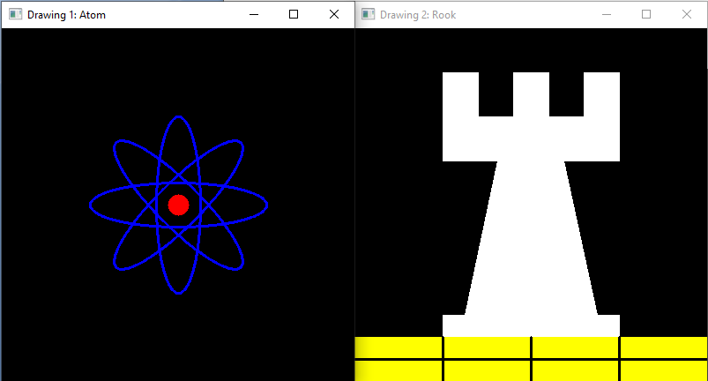

РОБОТА УСПІШНА!

**2) Random generator and text with OpenCV**

c = Drawing_Random_Lines(image, window_name, rng);  
if( c != 0 ) return 0;  
c = Drawing_Random_Rectangles(image, window_name, rng);  
if( c != 0 ) return 0;  
c = Drawing_Random_Ellipses( image, window_name, rng );  
if( c != 0 ) return 0;  
c = Drawing_Random_Polylines( image, window_name, rng );  
if( c != 0 ) return 0;  
c = Drawing_Random_Filled_Polygons( image, window_name, rng );  
if( c != 0 ) return 0;  
c = Drawing_Random_Circles( image, window_name, rng );  
if( c != 0 ) return 0;  
c = Displaying_Random_Text( image, window_name, rng );  
if( c != 0 ) return 0;  
c = Displaying_Big_End( image, window_name, rng );

1. Спочатку на екрані з’явиться випадковий набір із *NUMBER рядків, як це можна побачити на цьому скріншоті:*

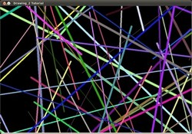

int Drawing_Random_Lines( Mat image, char* window_name, RNG rng )  
{  
 int lineType = 8;  
 Point pt1, pt2;  
 for( int i = 0; i < NUMBER; i++ )  
 {  
 pt1.x = rng.uniform( x_1, x_2 );  
 pt1.y = rng.uniform( y_1, y_2 );  
 pt2.x = rng.uniform( x_1, x_2 );  
 pt2.y = rng.uniform( y_1, y_2 );  
 line( image, pt1, pt2, randomColor(rng), rng.uniform(1, 10), 8 );  
 imshow( window_name, image );  
 if( waitKey( DELAY ) >= 0 )  
 { return -1; }  
 }  
 return 0;  
}

1. Потім буде новий набір фігур, ці часові *прямокутники .*
2. Тепер з’явиться кілька еліпсів, кожен з яких має випадкове положення, розмір, товщину та довжину дуги:

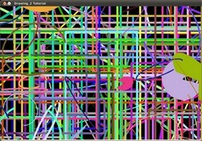

1. Тепер на екрані з’являться *полілінії з сегментами 03, знову ж у довільній конфігурації.*

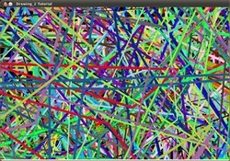

int Displaying_Random_Text( Mat image, char* window_name, RNG rng )  
{  
 int lineType = 8;  
 for ( int i = 1; i < NUMBER; i++ )  
 {  
 Point org;  
 org.x = rng.uniform(x_1, x_2);  
 org.y = rng.uniform(y_1, y_2);  
 putText( image, "Testing text rendering", org, rng.uniform(0,8),  
 rng.uniform(0,100)*0.05+0.1, randomColor(rng), rng.uniform(1, 10), lineType);  
 imshow( window_name, image );  
 if( waitKey(DELAY) >= 0 )  
 { return -1; }  
 }  
 return 0;  
}

int Displaying_Big_End( Mat image, char* window_name, RNG rng )  
{  
 Size textsize = getTextSize("OpenCV forever!", FONT_HERSHEY_COMPLEX, 3, 5, 0);  
 Point org((window_width - textsize.width)/2, (window_height - textsize.height)/2);  
 int lineType = 8;  
 Mat image2;  
 for( int i = 0; i < 255; i += 2 )  
 {  
 image2 = image - Scalar::all(i);  
 putText( image2, "OpenCV forever!", org, FONT_HERSHEY_COMPLEX, 3,  
 Scalar(i, i, 255), 5, lineType );  
 imshow( window_name, image2 );  
 if( waitKey(DELAY) >= 0 )  
 { return -1; }  
 }  
 return 0;  
}

1. Зафарбовані багатокутники (у цьому прикладі трикутники) підуть далі.
2. Остання з’явилася геометрична фігура: кола!

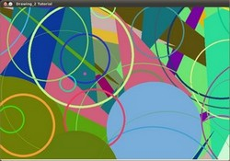

1. Ближче до кінця текст *"Тестування відтворення тексту"* з’явиться різними шрифтами, розмірами, кольорами та положеннями.
2. І великий кінець (який, до речі, теж виражає велику правду):

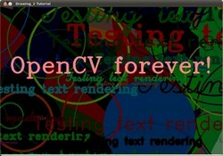

**3) Smoothing Images**

import sys  
import cv2 as cv  
import numpy as np  
  
# Global Variables  
DELAY_CAPTION = 1500  
DELAY_BLUR = 100  
MAX_KERNEL_LENGTH = 31  
src = None  
dst = None  
window_name = 'Smoothing Demo'  
  
  
def main(argv):  
 cv.namedWindow(window_name, cv.WINDOW_AUTOSIZE)  
 # Load the source image  
 imageName = argv[0] if len(argv) > 0 else 'G:/Python/lena.jpg'  
 global src  
 src = cv.imread(cv.samples.findFile(imageName))  
 #if src is None:  
 #print('Error opening image')  
 #print('Usage: smoothing.py [image_name -- default ../data/lena.jpg] \n')  
 #return -1  
 if display_caption('Original Image') != 0:  
 return 0  
 global dst  
 dst = np.copy(src)  
 if display_dst(DELAY_CAPTION) != 0:  
 return 0  
 # Applying Homogeneous blur  
 if display_caption('Homogeneous Blur') != 0:  
 return 0  
  
 for i in range(1, MAX_KERNEL_LENGTH, 2):  
 dst = cv.blur(src, (i, i))  
 if display_dst(DELAY_BLUR) != 0:  
 return 0  
  
 # Applying Gaussian blur  
 if display_caption('Gaussian Blur') != 0:  
 return 0  
  
 for i in range(1, MAX_KERNEL_LENGTH, 2):  
 dst = cv.GaussianBlur(src, (i, i), 0)  
 if display_dst(DELAY_BLUR) != 0:  
 return 0  
  
 # Applying Median blur  
 if display_caption('Median Blur') != 0:  
 return 0  
  
 for i in range(1, MAX_KERNEL_LENGTH, 2):  
 dst = cv.medianBlur(src, i)  
 if display_dst(DELAY_BLUR) != 0:  
 return 0  
  
 # Applying Bilateral Filter  
 if display_caption('Bilateral Blur') != 0:  
 return 0  
  
 for i in range(1, MAX_KERNEL_LENGTH, 2):  
 dst = cv.bilateralFilter(src, i, i * 2, i / 2)  
 if display_dst(DELAY_BLUR) != 0:  
 return 0  
  
 # Done  
 display_caption('Done!')  
 return 0  
  
  
def display_caption(caption):  
 global dst  
 dst = np.zeros(src.shape, src.dtype)  
 rows, cols, _ch = src.shape  
 cv.putText(dst, caption,  
 (int(cols / 4), int(rows / 2)),  
 cv.FONT_HERSHEY_COMPLEX, 1, (255, 255, 255))  
 return display_dst(DELAY_CAPTION)  
  
  
def display_dst(delay):  
 cv.imshow(window_name, dst)  
 c = cv.waitKey(delay)  
 if c >= 0: return -1  
 return 0  
  
  
if __name__ == "__main__":  
 main(sys.argv[1:])

Показує типи розмиття фото

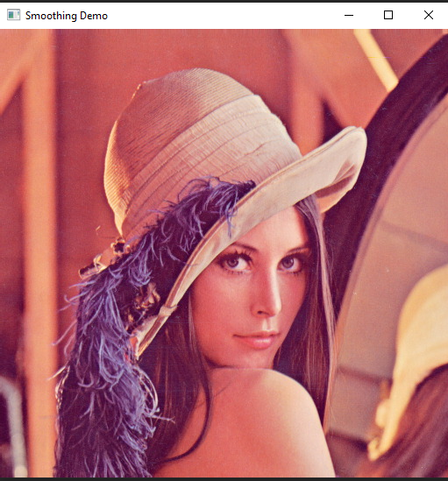

Original photo

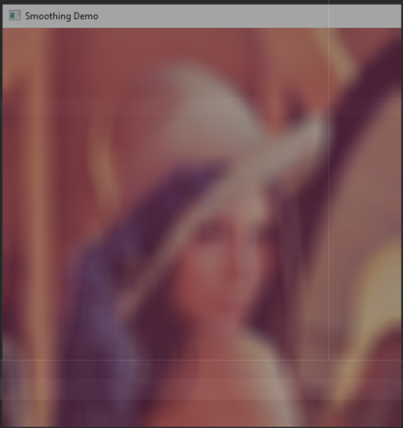

Homogeneous blur

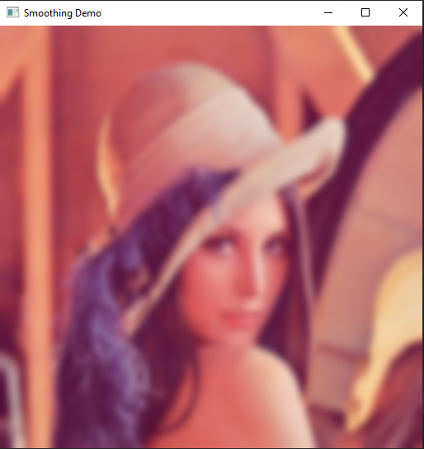

Gaussian blur

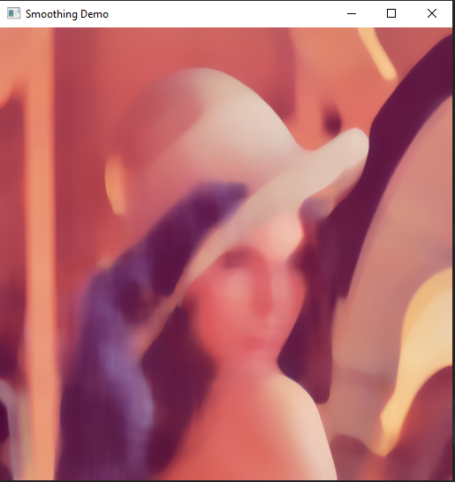

Median blur

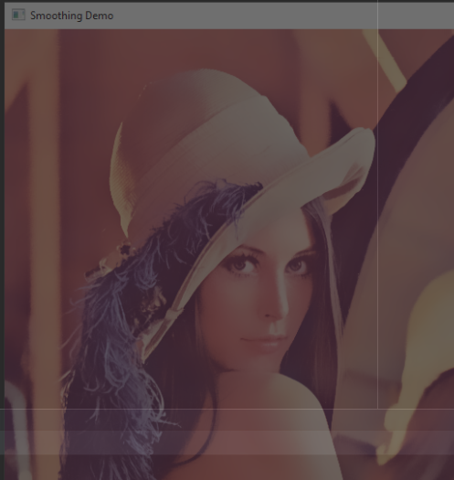

Bilateral photo

РОБОТА УСПІШНА!

**4) Eroding and Dilating**

БУЛО:

from __future__ import print_function  
import cv2 as cv  
import numpy as np  
import argparse  
  
src = None  
erosion_size = 0  
max_elem = 2  
max_kernel_size = 21  
title_trackbar_element_shape = 'Element:\n 0: Rect \n 1: Cross \n 2: Ellipse'  
title_trackbar_kernel_size = 'Kernel size:\n 2n +1'  
title_erosion_window = 'Erosion Demo'  
title_dilation_window = 'Dilation Demo'  
  
  
def main(image):  
 global src  
 src = cv.imread(cv.samples.findFile(image))  
 if src is None:  
 print('Could not open or find the image: ', image)  
 exit(0)  
 cv.namedWindow(title_erosion_window)  
 cv.createTrackbar(title_trackbar_element_shape, title_erosion_window, 0, max_elem, erosion)  
 cv.createTrackbar(title_trackbar_kernel_size, title_erosion_window, 0, max_kernel_size, erosion)  
 cv.namedWindow(title_dilation_window)  
 cv.createTrackbar(title_trackbar_element_shape, title_dilation_window, 0, max_elem, dilatation)  
 cv.createTrackbar(title_trackbar_kernel_size, title_dilation_window, 0, max_kernel_size, dilatation)  
 erosion(0)  
 dilatation(0)  
 cv.waitKey()  
  
  
# optional mapping of values with morphological shapes  
def morph_shape(val):  
 if val == 0:  
 return cv.MORPH_RECT  
 elif val == 1:  
 return cv.MORPH_CROSS  
 elif val == 2:  
 return cv.MORPH_ELLIPSE  
  
  
def erosion(val):  
 erosion_size = cv.getTrackbarPos(title_trackbar_kernel_size, title_erosion_window)  
 erosion_shape = morph_shape(cv.getTrackbarPos(title_trackbar_element_shape, title_erosion_window))  
  
 element = cv.getStructuringElement(erosion_shape, (2 * erosion_size + 1, 2 * erosion_size + 1),  
 (erosion_size, erosion_size))  
  
 erosion_dst = cv.erode(src, element)  
 cv.imshow(title_erosion_window, erosion_dst)  
  
  
def dilatation(val):  
 dilatation_size = cv.getTrackbarPos(title_trackbar_kernel_size, title_dilation_window)  
 dilation_shape = morph_shape(cv.getTrackbarPos(title_trackbar_element_shape, title_dilation_window))  
 element = cv.getStructuringElement(dilation_shape, (2 * dilatation_size + 1, 2 * dilatation_size + 1),  
 (dilatation_size, dilatation_size))  
 dilatation_dst = cv.dilate(src, element)  
 cv.imshow(title_dilation_window, dilatation_dst)  
  
  
if __name__ == "__main__":  
 parser = argparse.ArgumentParser(description='Code for Eroding and Dilating tutorial.')  
 parser.add_argument('--input', help='Path to input image.', default='G:/Python/LinuxLogo.jpg')  
 args = parser.parse_args()  
 main(args.input)

РОБОТА НЕУСПІШНА!

СТАЛО:

from __future__ import print_function  
import cv2 as cv  
import numpy as np  
import argparse  
  
src = None  
erosion_size = 0  
max_elem = 2  
max_kernel_size = 21  
title_trackbar_element_shape = 'Element:\n 0: Rect \n 1: Cross \n 2: Ellipse'  
title_trackbar_kernel_size = 'Kernel size:\n 2n +1'  
title_erosion_window = 'Erosion Demo'  
title_dilation_window = 'Dilation Demo'  
  
  
def main(image):  
 global src  
 src = cv.imread(cv.samples.findFile(image))  
 #if src is None:  
 #print('Could not open or find the image: ', image)  
 #exit(0)  
 cv.namedWindow(title_erosion_window)  
 cv.createTrackbar(title_trackbar_element_shape, title_erosion_window, 0, max_elem, erosion)  
 cv.createTrackbar(title_trackbar_kernel_size, title_erosion_window, 0, max_kernel_size, erosion)  
 cv.namedWindow(title_dilation_window)  
 cv.createTrackbar(title_trackbar_element_shape, title_dilation_window, 0, max_elem, dilatation)  
 cv.createTrackbar(title_trackbar_kernel_size, title_dilation_window, 0, max_kernel_size, dilatation)  
 erosion(0)  
 dilatation(0)  
 cv.waitKey()  
  
  
# optional mapping of values with morphological shapes  
def morph_shape(val):  
 if val == 0:  
 return cv.MORPH_RECT  
 elif val == 1:  
 return cv.MORPH_CROSS  
 elif val == 2:  
 return cv.MORPH_ELLIPSE  
  
  
def erosion(val):  
 erosion_size = cv.getTrackbarPos(title_trackbar_kernel_size, title_erosion_window)  
 erosion_shape = morph_shape(cv.getTrackbarPos(title_trackbar_element_shape, title_erosion_window))  
  
 element = cv.getStructuringElement(erosion_shape, (2 * erosion_size + 1, 2 * erosion_size + 1),  
 (erosion_size, erosion_size))  
  
 erosion_dst = cv.erode(src, element)  
 cv.imshow(title_erosion_window, erosion_dst)  
  
  
def dilatation(val):  
 dilatation_size = cv.getTrackbarPos(title_trackbar_kernel_size, title_dilation_window)  
 dilation_shape = morph_shape(cv.getTrackbarPos(title_trackbar_element_shape, title_dilation_window))  
 element = cv.getStructuringElement(dilation_shape, (2 * dilatation_size + 1, 2 * dilatation_size + 1),  
 (dilatation_size, dilatation_size))  
 dilatation_dst = cv.dilate(src, element)  
 cv.imshow(title_dilation_window, dilatation_dst)  
  
  
if __name__ == "__main__":  
 parser = argparse.ArgumentParser(description='Code for Eroding and Dilating tutorial.')  
 parser.add_argument('--input', help='Path to input image.', default='G:/Python/LinuxLogo.jpg')  
 args = parser.parse_args()  
 main(args.input)

Єдина проблема була у відступах. Через це виникало помилку!

Сам код робить фото з одного вікна затемнення, а з другого – освітлення.

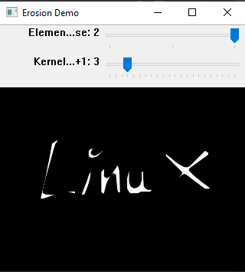

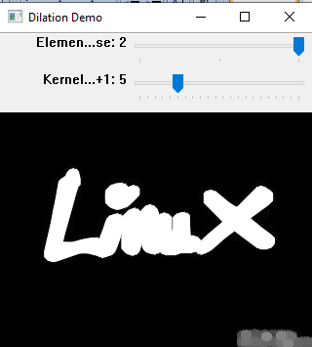

РОБОТА УСПІШНА!

**5) More Morphology Transformations**

БУЛО:

from __future__ import print_function  
import cv2 as cv  
import numpy as np  
import argparse  
morph_size = 0  
max_operator = 4  
max_elem = 2  
max_kernel_size = 21  
title_trackbar_operator_type = 'Operator:\n 0: Opening - 1: Closing \n 2: Gradient - 3: Top Hat \n 4: Black Hat'  
title_trackbar_element_type = 'Element:\n 0: Rect - 1: Cross - 2: Ellipse'  
title_trackbar_kernel_size = 'Kernel size:\n 2n + 1'  
title_window = 'Morphology Transformations Demo'  
morph_op_dic = {0: cv.MORPH_OPEN, 1: cv.MORPH_CLOSE, 2: cv.MORPH_GRADIENT, 3: cv.MORPH_TOPHAT, 4: cv.MORPH_BLACKHAT}  
def morphology_operations(val):  
 morph_operator = cv.getTrackbarPos(title_trackbar_operator_type, title_window)  
 morph_size = cv.getTrackbarPos(title_trackbar_kernel_size, title_window)  
 morph_elem = 0  
 val_type = cv.getTrackbarPos(title_trackbar_element_type, title_window)  
 if val_type == 0:  
morph_elem = cv.MORPH_RECT  
 elif val_type == 1:  
 morph_elem = cv.MORPH_CROSS  
 elif val_type == 2:  
 morph_elem = cv.MORPH_ELLIPSE  
 element = cv.getStructuringElement(morph_elem, (2*morph_size + 1, 2*morph_size+1), (morph_size, morph_size))  
 operation = morph_op_dic[morph_operator]  
 dst = cv.morphologyEx(src, operation, element)  
 cv.imshow(title_window, dst)  
parser = argparse.ArgumentParser(description='Code for More Morphology Transformations tutorial.')  
parser.add_argument('--input', help='Path to input image.', default='LinuxLogo.jpg')  
args = parser.parse_args()  
src = cv.imread(cv.samples.findFile(args.input))  
if src is None:  
 print('Could not open or find the image: ', args.input)  
 exit(0)  
cv.namedWindow(title_window)  
cv.createTrackbar(title_trackbar_operator_type, title_window , 0, max_operator, morphology_operations)  
cv.createTrackbar(title_trackbar_element_type, title_window , 0, max_elem, morphology_operations)  
cv.createTrackbar(title_trackbar_kernel_size, title_window , 0, max_kernel_size, morphology_operations)  
morphology_operations(0)  
cv.waitKey()

РОБОТА НЕУСПІШНА!

СТАЛО:

from __future__ import print_function  
import cv2 as cv  
import numpy as np  
import argparse  
morph_size = 0  
max_operator = 4  
max_elem = 2  
max_kernel_size = 21  
title_trackbar_operator_type = 'Operator:\n 0: Opening - 1: Closing \n 2: Gradient - 3: Top Hat \n 4: Black Hat'  
title_trackbar_element_type = 'Element:\n 0: Rect - 1: Cross - 2: Ellipse'  
title_trackbar_kernel_size = 'Kernel size:\n 2n + 1'  
title_window = 'Morphology Transformations Demo'  
morph_op_dic = {0: cv.MORPH_OPEN, 1: cv.MORPH_CLOSE, 2: cv.MORPH_GRADIENT, 3: cv.MORPH_TOPHAT, 4: cv.MORPH_BLACKHAT}  
def morphology_operations(val):  
 morph_operator = cv.getTrackbarPos(title_trackbar_operator_type, title_window)  
 morph_size = cv.getTrackbarPos(title_trackbar_kernel_size, title_window)  
 morph_elem = 0  
 val_type = cv.getTrackbarPos(title_trackbar_element_type, title_window)  
 if val_type == 0: morph_elem = cv.MORPH_RECT  
 elif val_type == 1: morph_elem = cv.MORPH_CROSS  
 elif val_type == 2: morph_elem = cv.MORPH_ELLIPSE  
 element = cv.getStructuringElement(morph_elem, (2*morph_size + 1, 2*morph_size+1), (morph_size, morph_size))  
 operation = morph_op_dic[morph_operator]  
 dst = cv.morphologyEx(src, operation, element)  
 cv.imshow(title_window, dst)  
parser = argparse.ArgumentParser(description='Code for More Morphology Transformations tutorial.')  
parser.add_argument('--input', help='Path to input image.', default='G:/Python/baboon.jpg')  
args = parser.parse_args()  
src = cv.imread(cv.samples.findFile(args.input))  
if src is None:  
 print('Could not open or find the image: ', args.input)  
 exit(0)  
cv.namedWindow(title_window)  
cv.createTrackbar(title_trackbar_operator_type, title_window , 0, max_operator, morphology_operations)  
cv.createTrackbar(title_trackbar_element_type, title_window , 0, max_elem, morphology_operations)  
cv.createTrackbar(title_trackbar_kernel_size, title_window , 0, max_kernel_size, morphology_operations)  
morphology_operations(0)  
cv.waitKey()

Єдина проблема була у відступах. Через це виникало помилку!

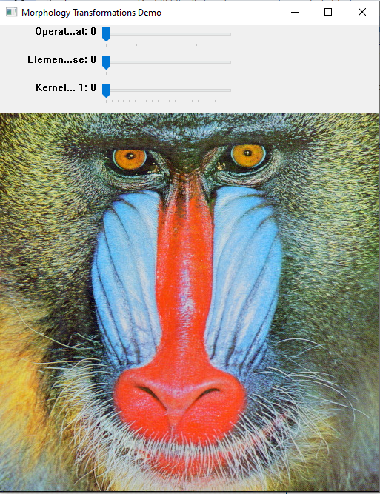

Тут є два знімки вікна дисплея. Перше зображення показує вихід після використання оператора **Opening** з перехресним ядром. Друге зображення перетворене на негатив. Справа в тому, що добавлено оператор **Black Hat** з ядром еліпса.

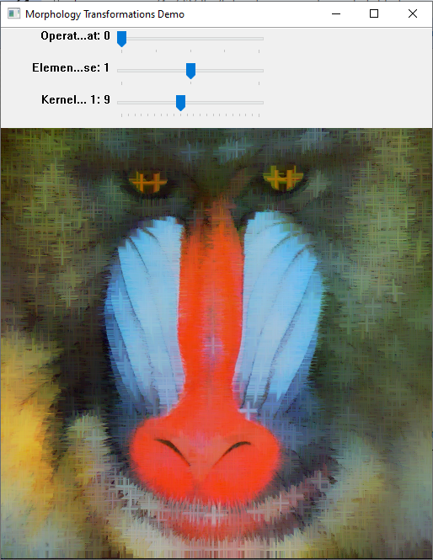

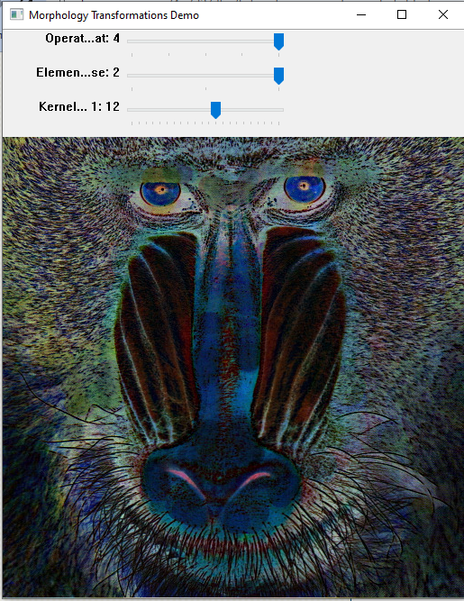

РОБОТА УСПІШНА!

**6) Hit-or-Miss**

import cv2 as cv  
import numpy as np  
input_image = np.array((  
 [0, 0, 0, 0, 0, 0, 0, 0],  
 [0, 255, 255, 255, 0, 0, 0, 255],  
 [0, 255, 255, 255, 0, 0, 0, 0],  
 [0, 255, 255, 255, 0, 255, 0, 0],  
 [0, 0, 255, 0, 0, 0, 0, 0],  
 [0, 0, 255, 0, 0, 255, 255, 0],  
 [0,255, 0, 255, 0, 0, 255, 0],  
 [0, 255, 255, 255, 0, 0, 0, 0]), dtype="uint8")  
kernel = np.array((  
 [0, 1, 0],  
 [1, -1, 1],  
 [0, 1, 0]), dtype="int")  
output_image = cv.morphologyEx(input_image, cv.MORPH_HITMISS, kernel)  
rate = 50  
kernel = (kernel + 1) * 127  
kernel = np.uint8(kernel)  
kernel = cv.resize(kernel, None, fx = rate, fy = rate, interpolation = cv.INTER_NEAREST)  
cv.imshow("kernel", kernel)  
cv.moveWindow("kernel", 0, 0)  
input_image = cv.resize(input_image, None, fx = rate, fy = rate, interpolation = cv.INTER_NEAREST)  
cv.imshow("Original", input_image)  
cv.moveWindow("Original", 0, 200)  
output_image = cv.resize(output_image, None , fx = rate, fy = rate, interpolation = cv.INTER_NEAREST)  
cv.imshow("Hit or Miss", output_image)  
cv.moveWindow("Hit or Miss", 500, 200)  
cv.waitKey(0)  
cv.destroyAllWindows()

Ця робота показує, як правильно малювати квадрати, не вгадуючи координат

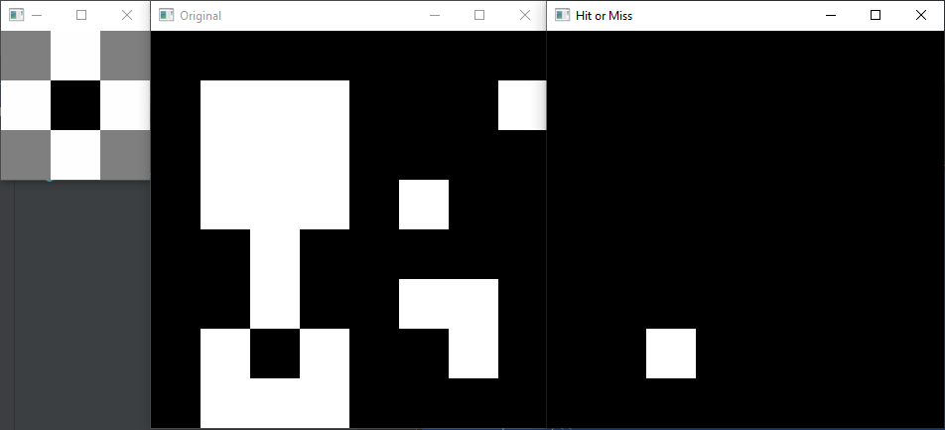

РОБОТА УСПІШНА!

**7) Extract horizontal and vertical lines by using morphological operations**

БУЛО:

import numpy as np  
import sys  
import cv2 as cv  
def show_wait_destroy(winname, img):  
 cv.imshow(winname, img)  
 cv.moveWindow(winname, 500, 0)  
 cv.waitKey(0)  
 cv.destroyWindow(winname)  
def main(argv):  
 # [load_image]  
 # Check number of arguments  
 if len(argv) < 1:  
 print ('Not enough parameters')  
 print ('Usage:\nmorph_lines_detection.py < path_to_image >')  
 return -1  
 # Load the image  
 src = cv.imread(argv[0], cv.IMREAD_COLOR)  
 # Check if image is loaded fine  
 if src is None:  
 print ('Error opening image: ' + argv[0])  
 return -1  
 # Show source image  
 cv.imshow("src", src)  
 # [load_image]  
 # [gray]  
 # Transform source image to gray if it is not already  
 if len(src.shape) != 2:  
 gray = cv.cvtColor(src, cv.COLOR_BGR2GRAY)  
 else:  
 gray = src  
 # Show gray image  
 show_wait_destroy("gray", gray)  
 # [gray]  
 # [bin]  
 # Apply adaptiveThreshold at the bitwise_not of gray, notice the ~ symbol  
 gray = cv.bitwise_not(gray)  
 bw = cv.adaptiveThreshold(gray, 255, cv.ADAPTIVE_THRESH_MEAN_C, \  
 cv.THRESH_BINARY, 15, -2)  
 # Show binary image  
 show_wait_destroy("binary", bw)  
 # [bin]  
 # [init]  
 # Create the images that will use to extract the horizontal and vertical lines  
 horizontal = np.copy(bw)  
 vertical = np.copy(bw)  
 # [init]  
 # [horiz]  
 # Specify size on horizontal axis  
 cols = horizontal.shape[1]  
 horizontal_size = cols // 30  
 # Create structure element for extracting horizontal lines through morphology operations  
 horizontalStructure = cv.getStructuringElement(cv.MORPH_RECT, (horizontal_size, 1))  
 # Apply morphology operations  
 horizontal = cv.erode(horizontal, horizontalStructure)  
 horizontal = cv.dilate(horizontal, horizontalStructure)  
 # Show extracted horizontal lines  
 show_wait_destroy("horizontal", horizontal)  
 # [horiz]  
 # [vert]  
 # Specify size on vertical axis  
 rows = vertical.shape[0]  
 verticalsize = rows // 30  
 # Create structure element for extracting vertical lines through morphology operations  
 verticalStructure = cv.getStructuringElement(cv.MORPH_RECT, (1, verticalsize))  
 # Apply morphology operations  
 vertical = cv.erode(vertical, verticalStructure)  
 vertical = cv.dilate(vertical, verticalStructure)  
 # Show extracted vertical lines  
 show_wait_destroy("vertical", vertical)  
 # [vert]  
 # [smooth]  
 # Inverse vertical image  
 vertical = cv.bitwise_not(vertical)  
 show_wait_destroy("vertical_bit", vertical)  
 '''  
 Extract edges and smooth image according to the logic  
 1. extract edges  
 2. dilate(edges)  
 3. src.copyTo(smooth)  
 4. blur smooth img  
 5. smooth.copyTo(src, edges)  
 '''  
 # Step 1  
 edges = cv.adaptiveThreshold(vertical, 255, cv.ADAPTIVE_THRESH_MEAN_C, \  
 cv.THRESH_BINARY, 3, -2)  
 show_wait_destroy("edges", edges)  
 # Step 2  
 kernel = np.ones((2, 2), np.uint8)  
 edges = cv.dilate(edges, kernel)  
 show_wait_destroy("dilate", edges)  
 # Step 3  
 smooth = np.copy(vertical)  
 # Step 4  
 smooth = cv.blur(smooth, (2, 2))  
 # Step 5  
 (rows, cols) = np.where(edges != 0)  
 vertical[rows, cols] = smooth[rows, cols]  
 # Show final result  
 show_wait_destroy("smooth - final", vertical)  
 # [smooth]  
 return 0  
if __name__ == "__main__":  
 main(sys.argv[1:])

РОБОТА НЕУСПІШНА!

СТАЛО:

import numpy as np  
import sys  
import cv2 as cv  
def show_wait_destroy(winname, img):  
 cv.imshow(winname, img)  
 cv.moveWindow(winname, 500, 0)  
 cv.waitKey(0)  
 cv.destroyWindow(winname)  
def main(argv):  
 # [load_image]  
 # Check number of arguments  
 if len(argv) < 1:  
 print ('Not enough parameters')  
 print ('Usage:\nmorph_lines_detection.py < path_to_image >')  
 return -1  
 # Load the image  
 src = cv.imread(argv[0], cv.IMREAD_COLOR)  
 # Check if image is loaded fine  
 if src is None:  
 print ('Error opening image: ' + argv[0])  
 return -1  
 # Show source image  
 cv.imshow("src", src)  
 # [load_image]  
 # [gray]  
 # Transform source image to gray if it is not already  
 if len(src.shape) != 2:  
 gray = cv.cvtColor(src, cv.COLOR_BGR2GRAY)  
 else:  
 gray = src  
 # Show gray image  
 show_wait_destroy("gray", gray)  
 # [gray]  
 # [bin]  
 # Apply adaptiveThreshold at the bitwise_not of gray, notice the ~ symbol  
 gray = cv.bitwise_not(gray)  
 bw = cv.adaptiveThreshold(gray, 255, cv.ADAPTIVE_THRESH_MEAN_C, \  
 cv.THRESH_BINARY, 15, -2)  
 # Show binary image  
 show_wait_destroy("binary", bw)  
 # [bin]  
 # [init]  
 # Create the images that will use to extract the horizontal and vertical lines  
 horizontal = np.copy(bw)  
 vertical = np.copy(bw)  
 # [init]  
 # [horiz]  
 # Specify size on horizontal axis  
 cols = horizontal.shape[1]  
 horizontal_size = cols // 30  
 # Create structure element for extracting horizontal lines through morphology operations  
 horizontalStructure = cv.getStructuringElement(cv.MORPH_RECT, (horizontal_size, 1))  
 # Apply morphology operations  
 horizontal = cv.erode(horizontal, horizontalStructure)  
 horizontal = cv.dilate(horizontal, horizontalStructure)  
 # Show extracted horizontal lines  
 show_wait_destroy("horizontal", horizontal)  
 # [horiz]  
 # [vert]  
 # Specify size on vertical axis  
 rows = vertical.shape[0]  
 verticalsize = rows // 30  
 # Create structure element for extracting vertical lines through morphology operations  
 verticalStructure = cv.getStructuringElement(cv.MORPH_RECT, (1, verticalsize))  
 # Apply morphology operations  
 vertical = cv.erode(vertical, verticalStructure)  
 vertical = cv.dilate(vertical, verticalStructure)  
 # Show extracted vertical lines  
 show_wait_destroy("vertical", vertical)  
 # [vert]  
 # [smooth]  
 # Inverse vertical image  
 vertical = cv.bitwise_not(vertical)  
 show_wait_destroy("vertical_bit", vertical)  
 '''  
 Extract edges and smooth image according to the logic  
 1. extract edges  
 2. dilate(edges)  
 3. src.copyTo(smooth)  
 4. blur smooth img  
 5. smooth.copyTo(src, edges)  
 '''  
 # Step 1  
 edges = cv.adaptiveThreshold(vertical, 255, cv.ADAPTIVE_THRESH_MEAN_C, \  
 cv.THRESH_BINARY, 3, -2)  
 show_wait_destroy("edges", edges)  
 # Step 2  
 kernel = np.ones((2, 2), np.uint8)  
 edges = cv.dilate(edges, kernel)  
 show_wait_destroy("dilate", edges)  
 # Step 3  
 smooth = np.copy(vertical)  
 # Step 4  
 smooth = cv.blur(smooth, (2, 2))  
 # Step 5  
 (rows, cols) = np.where(edges != 0)  
 vertical[rows, cols] = smooth[rows, cols]  
 # Show final result  
 show_wait_destroy("smooth - final", vertical)  
 # [smooth]  
 return 0  
if __name__ == "__main__":  
 main(sys.argv[1:])

Єдина проблема була у відступах. Через це виникало помилку!

Воно перетворює елементи із чорного на біле та наоборот.

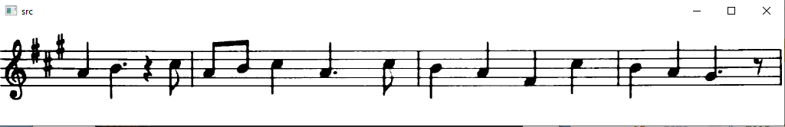

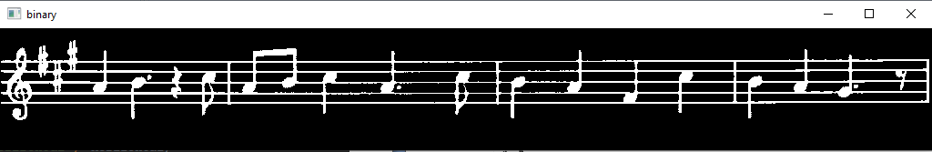

**8) Image Pyramids**

БУЛО:

import sys  
import cv2 as cv  
  
  
def main(argv):  
 print("""  
 Zoom In-Out demo  
 ------------------  
 * [i] -> Zoom [i]n  
 * [o] -> Zoom [o]ut  
 * [ESC] -> Close program  
 """)  
  
 filename = argv[0] if len(argv) > 0 else 'G:/Python/chicky_512.png'  
 # Load the image  
 src = cv.imread(cv.samples.findFile(filename))  
 # Check if image is loaded fine  
 if src is None:  
 print('Error opening image!')  
 print('Usage: pyramids.py [image_name -- default ../data/chicky_512.png] \n')  
 return -1  
  
 while 1:  
 rows, cols, _channels = map(int, src.shape)  
  
 cv.imshow('Pyramids Demo', src)  
  
 k = cv.waitKey(0)  
 if k == 27:  
 break  
  
 elif chr(k) == 'i':  
 src = cv.pyrUp(src, dstsize=(2 * cols, 2 * rows))  
 print('** Zoom In: Image x 2')  
  
 elif chr(k) == 'o':  
 src = cv.pyrDown(src, dstsize=(cols // 2, rows // 2))  
 print('** Zoom Out: Image / 2')  
  
 cv.destroyAllWindows()  
 return 0  
  
  
if __name__ == "__main__":  
 main(sys.argv[1:])

РОБОТА НЕУСПІШНА!

СТАЛО:

import sys  
import cv2 as cv  
  
  
def main(argv):  
 print("""  
 Zoom In-Out demo  
 ------------------  
 * [i] -> Zoom [i]n  
 * [o] -> Zoom [o]ut  
 * [ESC] -> Close program  
 """)  
  
 filename = argv[0] if len(argv) > 0 else 'G:/Python/chicky_512.png'  
 # Load the image  
 src = cv.imread(cv.samples.findFile(filename))  
 # Check if image is loaded fine  
 if src is None:  
 print('Error opening image!')  
 print('Usage: pyramids.py [image_name -- default ../data/chicky_512.png] \n')  
 return -1  
  
 while 1:  
 rows, cols, _channels = map(int, src.shape)  
  
 cv.imshow('Pyramids Demo', src)  
  
 k = cv.waitKey(0)  
 if k == 27: break  
  
 elif chr(k) == 'i':  
 src = cv.pyrUp(src, dstsize=(2 * cols, 2 * rows))  
 print('** Zoom In: Image x 2')  
  
 elif chr(k) == 'o':  
 src = cv.pyrDown(src, dstsize=(cols // 2, rows // 2))  
 print('** Zoom Out: Image / 2')  
  
 cv.destroyAllWindows()  
 return 0  
  
  
if __name__ == "__main__":  
 main(sys.argv[1:])

Єдина проблема була у відступах. Через це виникало помилку!

Код дає функцію збільшити або зменшити фото.

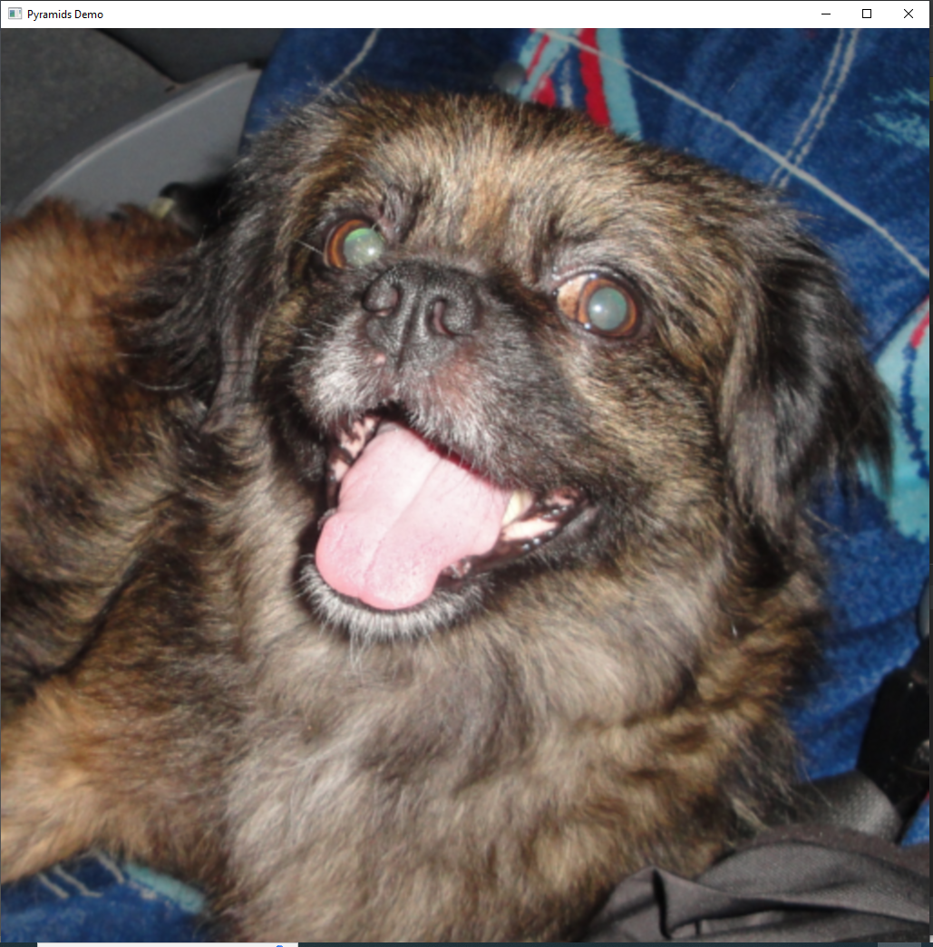

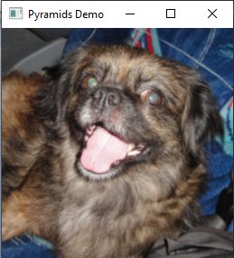

РОБОТА УСПІШНА!

**9) Basic Thresholding Operations**

from __future__ import print_function  
import cv2 as cv  
import argparse  
max_value = 255  
max_type = 4  
max_binary_value = 255  
trackbar_type = ‘Type: \n 0: Binary \n 1: Binary Inverted \n 2: Truncate \n 3: To Zero \n 4: To Zero Inverted’  
trackbar_value = ‘Value’  
window_name = ‘Threshold Demo’  
def Threshold_Demo(val):  
 #0: Binary  
 #1: Binary Inverted  
 #2: Threshold Truncated  
 #3: Threshold to Zero  
 #4: Threshold to Zero Inverted  
 threshold_type = cv.getTrackbarPos(trackbar_type, window_name)  
 threshold_value = cv.getTrackbarPos(trackbar_value, window_name)  
 _, dst = cv.threshold(src_gray, threshold_value, max_binary_value, threshold_type )  
 cv.imshow(window_name, dst)  
parser = argparse.ArgumentParser(description=’Code for Basic Thresholding Operations tutorial.’)  
parser.add_argument(‘—input’, help=’Path to input image.’, default=’G:/Python/stuff.jpg’)  
args = parser.parse_args()  
src = cv.imread(cv.samples.findFile(args.input))  
if src is None:  
 print(‘Could not open or find the image: ‘, args.input)  
 exit(0)  
# Convert the image to Gray  
src_gray = cv.cvtColor(src, cv.COLOR_BGR2GRAY)  
cv.namedWindow(window_name)  
cv.createTrackbar(trackbar_type, window_name , 3, max_type, Threshold_Demo)  
# Create Trackbar to choose Threshold value  
cv.createTrackbar(trackbar_value, window_name , 0, max_value, Threshold_Demo)  
# Call the function to initialize  
Threshold_Demo(0)  
# Wait until user finishes program  
cv.waitKey()

Цей код ми використовуємо для фото stuff.jpg.

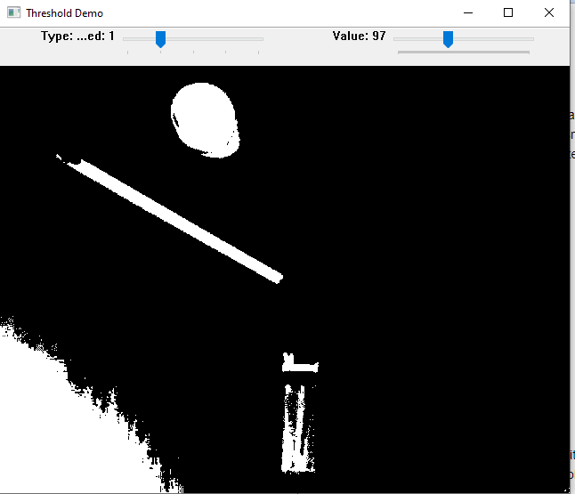

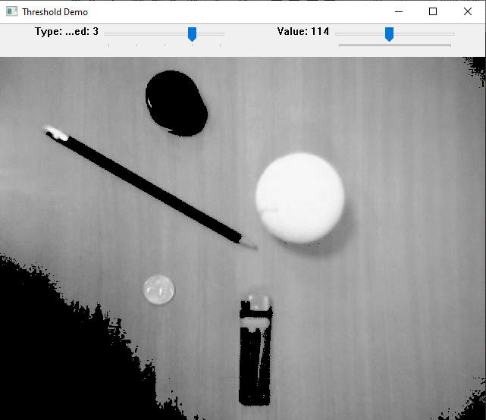

Тепер працюємо з фотом chicky_512.png.

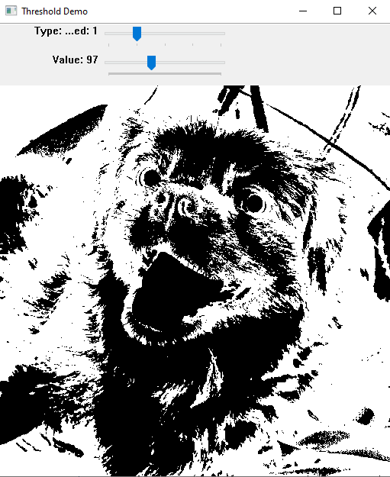

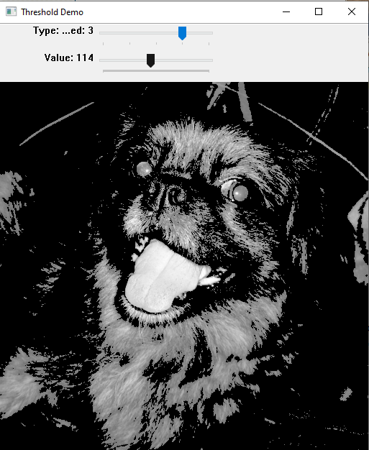

РОБОТА УСПІШНА!

**10) Thresholding Operations using inRange**

БУЛО:

from __future__ import print_function  
import cv2 as cv  
import argparse  
  
max_value = 255  
max_value_H = 360 // 2  
low_H = 0  
low_S = 0  
low_V = 0  
high_H = max_value_H  
high_S = max_value  
high_V = max_value  
window_capture_name = ‘Video Capture’  
window_detection_name = ‘Object Detection’  
low_H_name = ‘Low H’  
low_S_name = ‘Low S’  
low_V_name = ‘Low V’  
high_H_name = ‘High H’  
high_S_name = ‘High S’  
high_V_name = ‘High V’  
  
  
def on_low_H_thresh_trackbar(val):  
 global low_H  
 global high_H  
 low_H = val  
 low_H = min(high_H — 1, low_H)  
 cv.setTrackbarPos(low_H_name, window_detection_name, low_H)  
  
  
def on_high_H_thresh_trackbar(val):  
 global low_H  
 global high_H  
 high_H = val  
 high_H = max(high_H, low_H + 1)  
 cv.setTrackbarPos(high_H_name, window_detection_name, high_H)  
  
  
def on_low_S_thresh_trackbar(val):  
 global low_S  
 global high_S  
 low_S = val  
 low_S = min(high_S — 1, low_S)  
 cv.setTrackbarPos(low_S_name, window_detection_name, low_S)  
  
  
def on_high_S_thresh_trackbar(val):  
 global low_S  
 global high_S  
 high_S = val  
 high_S = max(high_S, low_S + 1)  
 cv.setTrackbarPos(high_S_name, window_detection_name, high_S)  
  
  
def on_low_V_thresh_trackbar(val):  
 global low_V  
 global high_V  
 low_V = val  
 low_V = min(high_V — 1, low_V)  
 cv.setTrackbarPos(low_V_name, window_detection_name, low_V)  
  
  
def on_high_V_thresh_trackbar(val):  
 global low_V  
 global high_V  
 high_V = val  
 high_V = max(high_V, low_V + 1)  
 cv.setTrackbarPos(high_V_name, window_detection_name, high_V)  
  
  
parser = argparse.ArgumentParser(description=’Code for Thresholding Operations using inRange tutorial.’)  
parser.add_argument(‘—camera’, help=’Camera divide number.’, default=0, type=int)  
args = parser.parse_args()  
cap = cv.VideoCapture(args.camera)  
cv.namedWindow(window_capture_name)  
cv.namedWindow(window_detection_name)  
cv.createTrackbar(low_H_name, window_detection_name, low_H, max_value_H, on_low_H_thresh_trackbar)  
cv.createTrackbar(high_H_name, window_detection_name, high_H, max_value_H, on_high_H_thresh_trackbar)  
cv.createTrackbar(low_S_name, window_detection_name, low_S, max_value, on_low_S_thresh_trackbar)  
cv.createTrackbar(high_S_name, window_detection_name, high_S, max_value, on_high_S_thresh_trackbar)  
cv.createTrackbar(low_V_name, window_detection_name, low_V, max_value, on_low_V_thresh_trackbar)  
cv.createTrackbar(high_V_name, window_detection_name, high_V, max_value, on_high_V_thresh_trackbar)  
while True:  
  
 ret, frame = cap.read()  
 if frame is None:  
 break  
 frame_HSV = cv.cvtColor(frame, cv.COLOR_BGR2HSV)  
 frame_threshold = cv.inRange(frame_HSV, (low_H, low_S, low_V), (high_H, high_S, high_V))  
  
 cv.imshow(window_capture_name, frame)  
 cv.imshow(window_detection_name, frame_threshold)  
  
 key = cv.waitKey(30)  
 if key == ord(‘q’) or key == 27:  
 break

РОБОТА НЕУСПІШНА!

СТАЛО:

from __future__ import print_function  
import cv2 as cv  
#import argparse  
  
max_value = 255  
max_value_H = 360 // 2  
low_H = 0  
low_S = 0  
low_V = 0  
high_H = max_value_H  
high_S = max_value  
high_V = max_value  
window_capture_name = ‘Video Capture’  
window_detection_name = ‘Object Detection’  
low_H_name = ‘Low H’  
low_S_name = ‘Low S’  
low_V_name = ‘Low V’  
high_H_name = ‘High H’  
high_S_name = ‘High S’  
high_V_name = ‘High V’  
  
  
def on_low_H_thresh_trackbar(val):  
 global low_H  
 global high_H  
 low_H = val  
 low_H = min(high_H — 1, low_H)  
 cv.setTrackbarPos(low_H_name, window_detection_name, low_H)  
  
  
def on_high_H_thresh_trackbar(val):  
 global low_H  
 global high_H  
 high_H = val  
 high_H = max(high_H, low_H + 1)  
 cv.setTrackbarPos(high_H_name, window_detection_name, high_H)  
  
  
def on_low_S_thresh_trackbar(val):  
 global low_S  
 global high_S  
 low_S = val  
 low_S = min(high_S — 1, low_S)  
 cv.setTrackbarPos(low_S_name, window_detection_name, low_S)  
  
  
def on_high_S_thresh_trackbar(val):  
 global low_S  
 global high_S  
 high_S = val  
 high_S = max(high_S, low_S + 1)  
 cv.setTrackbarPos(high_S_name, window_detection_name, high_S)  
  
  
def on_low_V_thresh_trackbar(val):  
 global low_V  
 global high_V  
 low_V = val  
 low_V = min(high_V — 1, low_V)  
 cv.setTrackbarPos(low_V_name, window_detection_name, low_V)  
  
  
def on_high_V_thresh_trackbar(val):  
 global low_V  
 global high_V  
 high_V = val  
 high_V = max(high_V, low_V + 1)  
 cv.setTrackbarPos(high_V_name, window_detection_name, high_V)  
  
  
#parser = argparse.ArgumentParser(description=’Code for Thresholding Operations using inRange tutorial.’)  
#parser.add_argument(‘—input’, help=’Camera divide number.’, default=0, type=int)  
#args = parser.parse_args()  
cap = cv.VideoCapture(«G:/Python/lena.jpg»)  
cv.namedWindow(window_capture_name)  
cv.namedWindow(window_detection_name)  
cv.createTrackbar(low_H_name, window_detection_name, low_H, max_value_H, on_low_H_thresh_trackbar)  
cv.createTrackbar(high_H_name, window_detection_name, high_H, max_value_H, on_high_H_thresh_trackbar)  
cv.createTrackbar(low_S_name, window_detection_name, low_S, max_value, on_low_S_thresh_trackbar)  
cv.createTrackbar(high_S_name, window_detection_name, high_S, max_value, on_high_S_thresh_trackbar)  
cv.createTrackbar(low_V_name, window_detection_name, low_V, max_value, on_low_V_thresh_trackbar)  
cv.createTrackbar(high_V_name, window_detection_name, high_V, max_value, on_high_V_thresh_trackbar)  
ret, frame = cap.read()  
while True:  
 if frame is None:  
 break  
 frame_HSV = cv.cvtColor(frame, cv.COLOR_BGR2HSV)  
 frame_threshold = cv.inRange(frame_HSV, (low_H, low_S, low_V), (high_H, high_S, high_V))  
  
 cv.imshow(window_capture_name, frame)  
 cv.imshow(window_detection_name, frame_threshold)  
  
 key = cv.waitKey(30)  
 if key == ord(‘q’) or key == 27:  
 break

Ця робота мала підійти до камери, але оскільки камери не було, то ми до експерименту взяли фото **lena.jpg**. Воно змінювало фото на чорно-білий фон. Тобто там використовується колірний простір HSV. Де насиченості (Saturation) є білим, а значення кольору (Value) – чорним.

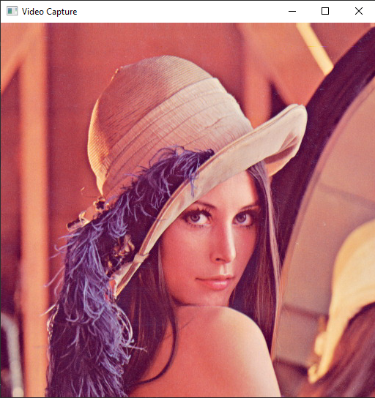

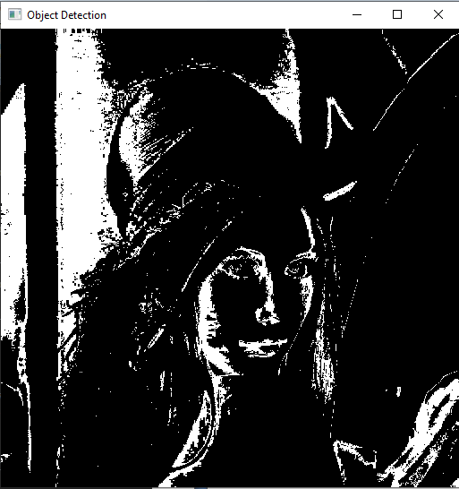

РОБОТА УСПІШНА!

**11) Making your own linear filters!**

БУЛО:

import sys  
import cv2 as cv  
import numpy as np  
  
  
def main(argv):  
 window_name = 'filter2D Demo'  
  
 imageName = argv[0] if len(argv) > 0 else 'lena.jpg'  
 # Loads an image  
 src = cv.imread(cv.samples.findFile(imageName), cv.IMREAD_COLOR)  
 # Check if image is loaded fine  
 if src is None:  
 print('Error opening image!')  
 print('Usage: filter2D.py [image_name -- default lena.jpg] \n')  
 return -1  
  
 ddepth = -1  
  
 ind = 0  
 while True:  
  
 kernel_size = 3 + 2 * (ind % 5)  
 kernel = np.ones((kernel_size, kernel_size), dtype=np.float32)  
 kernel /= (kernel_size * kernel_size)  
  
 dst = cv.filter2D(src, ddepth, kernel)  
  
 cv.imshow(window_name, dst)  
 c = cv.waitKey(500)  
 if c == 27:  
 break  
 ind += 1  
 return 0  
  
  
if __name__ == "__main__":  
 main(sys.argv[1:])

РОБОТА НЕУСПІШНА!

СТАЛО:

import sys  
import cv2 as cv  
import numpy as np  
  
  
def main(argv):  
 window_name = 'filter2D Demo'  
  
 imageName = argv[0] if len(argv) > 0 else 'G:/Python/lena.jpg'  
 # Loads an image  
 src = cv.imread(cv.samples.findFile(imageName), cv.IMREAD_COLOR)  
 # Check if image is loaded fine  
 if src is None:  
 print('Error opening image!')  
 print('Usage: filter2D.py [image_name -- default lena.jpg] \n')  
 return -1  
  
 ddepth = -1  
  
 ind = 0  
 while True:  
 kernel_size = 3 + 2 * (ind % 5)  
 kernel = np.ones((kernel_size, kernel_size), dtype=np.float32)  
 kernel /= (kernel_size * kernel_size)  
  
 dst = cv.filter2D(src, ddepth, kernel)  
  
 cv.imshow(window_name, dst)  
 c = cv.waitKey(500)  
 if c == 27: break  
 ind += 1  
 return 0  
  
  
if __name__ == "__main__":  
 main(sys.argv[1:])

Єдина проблема була у відступах. Через це виникало помилку!

Цей код показує етап розмиття фото.

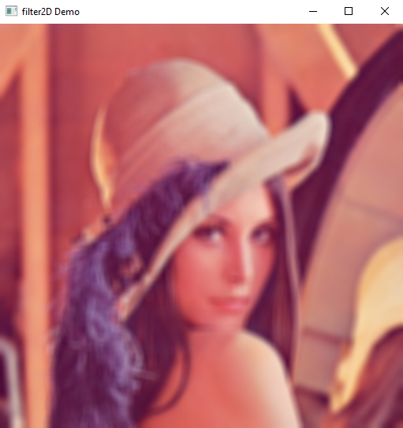

РОБОТА УСПІШНА!

**12) Adding borders to your images**

БУЛО:

import sys  
from random import randint  
import cv2 as cv  
  
  
def main(argv):  
 borderType = cv.BORDER_CONSTANT  
 window_name = "copyMakeBorder Demo"  
  
 imageName = argv[0] if len(argv) > 0 else 'G:/Python/lena.jpg'  
 # Loads an image  
 src = cv.imread(cv.samples.findFile(imageName), cv.IMREAD_COLOR)  
 # Check if image is loaded fine  
 if src is None:  
 print('Error opening image!')  
 print('Usage: copy_make_border.py [image_name -- default lena.jpg] \n')  
 return -1  
  
 print('\n'  
 '\t copyMakeBorder Demo: \n'  
 ' -------------------- \n'  
 ' ** Press \'c\' to set the border to a random constant value \n'  
 ' ** Press \'r\' to set the border to be replicated \n'  
 ' ** Press \'ESC\' to exit the program ')  
  
 cv.namedWindow(window_name, cv.WINDOW_AUTOSIZE)  
  
 top = int(0.05 * src.shape[0]) # shape[0] = rows  
 bottom = top  
 left = int(0.05 * src.shape[1]) # shape[1] = cols  
 right = left  
  
 while 1:  
  
 value = [randint(0, 255), randint(0, 255), randint(0, 255)]  
  
 dst = cv.copyMakeBorder(src, top, bottom, left, right, borderType, None, value)  
  
 cv.imshow(window_name, dst)  
  
 c = cv.waitKey(500)  
 if c == 27:  
 break  
 elif c == 99: # 99 = ord('c')  
 borderType = cv.BORDER_CONSTANT  
 elif c == 114: # 114 = ord('r')  
 borderType = cv.BORDER_REPLICATE  
  
 return 0  
  
  
if __name__ == "__main__":  
 main(sys.argv[1:])

РОБОТА НЕУСПІШНА!

СТАЛО:

import sys  
from random import randint  
import cv2 as cv  
  
  
def main(argv):  
 borderType = cv.BORDER_CONSTANT  
 window_name = "copyMakeBorder Demo"  
  
 imageName = argv[0] if len(argv) > 0 else 'G:/Python/lena.jpg'  
 # Loads an image  
 src = cv.imread(cv.samples.findFile(imageName), cv.IMREAD_COLOR)  
 # Check if image is loaded fine  
 if src is None:  
 print('Error opening image!')  
 print('Usage: copy_make_border.py [image_name -- default lena.jpg] \n')  
 return -1  
  
 print('\n'  
 '\t copyMakeBorder Demo: \n'  
 ' -------------------- \n'  
 ' ** Press \'c\' to set the border to a random constant value \n'  
 ' ** Press \'r\' to set the border to be replicated \n'  
 ' ** Press \'ESC\' to exit the program ')  
  
 cv.namedWindow(window_name, cv.WINDOW_AUTOSIZE)  
  
 top = int(0.05 * src.shape[0]) # shape[0] = rows  
 bottom = top  
 left = int(0.05 * src.shape[1]) # shape[1] = cols  
 right = left  
  
 while 1:  
  
 value = [randint(0, 255), randint(0, 255), randint(0, 255)]  
  
 dst = cv.copyMakeBorder(src, top, bottom, left, right, borderType, None, value)  
  
 cv.imshow(window_name, dst)  
  
 c = cv.waitKey(500)  
 if c == 27: break  
 elif c == 99: # 99 = ord('c')  
 borderType = cv.BORDER_CONSTANT  
 elif c == 114: # 114 = ord('r')  
 borderType = cv.BORDER_REPLICATE  
  
 return 0  
  
  
if __name__ == "__main__":  
 main(sys.argv[1:])

Єдина проблема була у відступах. Через це виникало помилку!

Цей код робить навколо фото різнокольорові рамки однієї товщини.

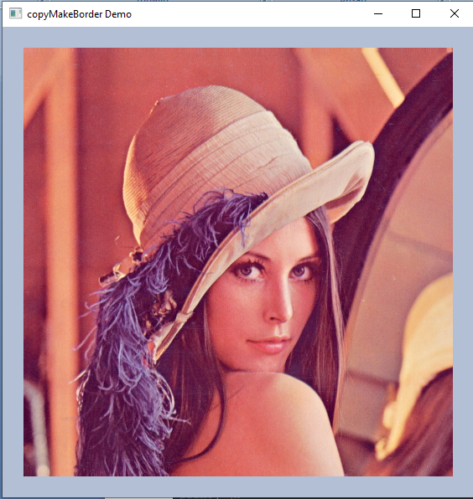

РОБОТА УСПІШНА!

**13) Sobel Derivatives**

import sys  
import cv2 as cv  
  
  
def main(argv):  
 window_name = ('Sobel Demo - Simple Edge Detector')  
 scale = 1  
 delta = 0  
 ddepth = cv.CV_16S  
  
 if len(argv) < 1:  
 print('Not enough parameters')  
 print('Usage:\nmorph_lines_detection.py < path_to_image >')  
 return -1  
 # Load the image  
 src = cv.imread(argv[0], cv.IMREAD_COLOR)  
 # Check if image is loaded fine  
 if src is None:  
 print('Error opening image: ' + argv[0])  
 return -1  
  
 src = cv.GaussianBlur(src, (3, 3), 0)  
  
 gray = cv.cvtColor(src, cv.COLOR_BGR2GRAY)  
  
 grad_x = cv.Sobel(gray, ddepth, 1, 0, ksize=3, scale=scale, delta=delta, borderType=cv.BORDER_DEFAULT)  
 # Gradient-Y  
 # grad_y = cv.Scharr(gray,ddepth,0,1)  
 grad_y = cv.Sobel(gray, ddepth, 0, 1, ksize=3, scale=scale, delta=delta, borderType=cv.BORDER_DEFAULT)  
  
 abs_grad_x = cv.convertScaleAbs(grad_x)  
 abs_grad_y = cv.convertScaleAbs(grad_y)  
  
 grad = cv.addWeighted(abs_grad_x, 0.5, abs_grad_y, 0.5, 0)  
  
 cv.imshow(window_name, grad)  
 cv.waitKey(0)  
  
 return 0  
  
  
if __name__ == "__main__":  
 main(sys.argv[1:])

Перетворює фото негативним

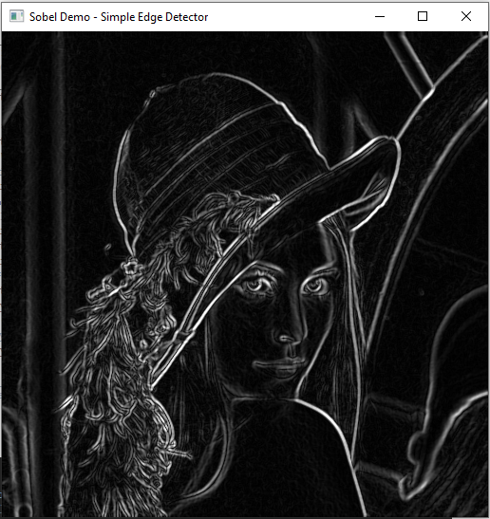

РОБОТА УСПІШНА!

**14) Laplace Operator**

БУЛО:

import sys  
import cv2 as cv  
def main(argv):  
 # [variables]  
 # Declare the variables we are going to use  
 ddepth = cv.CV_16S  
 kernel_size = 3  
 window_name = "Laplace Demo"  
 # [variables]  
 # [load]  
 imageName = argv[0] if len(argv) > 0 else 'lena.jpg'  
 src = cv.imread(cv.samples.findFile(imageName), cv.IMREAD_COLOR) # Load an image  
 # Check if image is loaded fine  
 if src is None:  
 print ('Error opening image')  
 print ('Program Arguments: [image_name -- default lena.jpg]')  
 return -1  
 # [load]  
 # [reduce_noise]  
 # Remove noise by blurring with a Gaussian filter  
 src = cv.GaussianBlur(src, (3, 3), 0)  
 # [reduce_noise]  
 # [convert_to_gray]  
 # Convert the image to grayscale  
 src_gray = cv.cvtColor(src, cv.COLOR_BGR2GRAY)  
 # [convert_to_gray]  
 # Create Window  
 cv.namedWindow(window_name, cv.WINDOW_AUTOSIZE)  
 # [laplacian]  
 # Apply Laplace function  
 dst = cv.Laplacian(src_gray, ddepth, ksize=kernel_size)  
 # [laplacian]  
 # [convert]  
 # converting back to uint8  
 abs_dst = cv.convertScaleAbs(dst)  
 # [convert]  
 # [display]  
 cv.imshow(window_name, abs_dst)  
 cv.waitKey(0)  
 # [display]  
 return 0  
if __name__ == "__main__":  
 main(sys.argv[1:])

РОБОТА НЕУСПІШНА!

СТАЛО:

import sys  
import cv2 as cv  
def main(argv):  
 # [variables]  
 # Declare the variables we are going to use  
 ddepth = cv.CV_16S  
 kernel_size = 3  
 window_name = "Laplace Demo"  
 # [variables]  
 # [load]  
 imageName = argv[0] if len(argv) > 0 else 'G:/Python/lena.jpg'  
 src = cv.imread(cv.samples.findFile(imageName), cv.IMREAD_COLOR) # Load an image  
 # Check if image is loaded fine  
 if src is None:  
 print ('Error opening image')  
 print ('Program Arguments: [image_name -- default lena.jpg]')  
 return -1  
 # [load]  
 # [reduce_noise]  
 # Remove noise by blurring with a Gaussian filter  
 src = cv.GaussianBlur(src, (3, 3), 0)  
 # [reduce_noise]  
 # [convert_to_gray]  
 # Convert the image to grayscale  
 src_gray = cv.cvtColor(src, cv.COLOR_BGR2GRAY)  
 # [convert_to_gray]  
 # Create Window  
 cv.namedWindow(window_name, cv.WINDOW_AUTOSIZE)  
 # [laplacian]  
 # Apply Laplace function  
 dst = cv.Laplacian(src_gray, ddepth, ksize=kernel_size)  
 # [laplacian]  
 # [convert]  
 # converting back to uint8  
 abs_dst = cv.convertScaleAbs(dst)  
 # [convert]  
 # [display]  
 cv.imshow(window_name, abs_dst)  
 cv.waitKey(0)  
 # [display]  
 return 0  
if __name__ == "__main__":  
 main(sys.argv[1:])

Єдина проблема була у відступах. Через це виникало помилку!

Цей код схожий із попереднім, тільки воно виглядає більш пісочним. Бо на фото є маленькі цяточки.

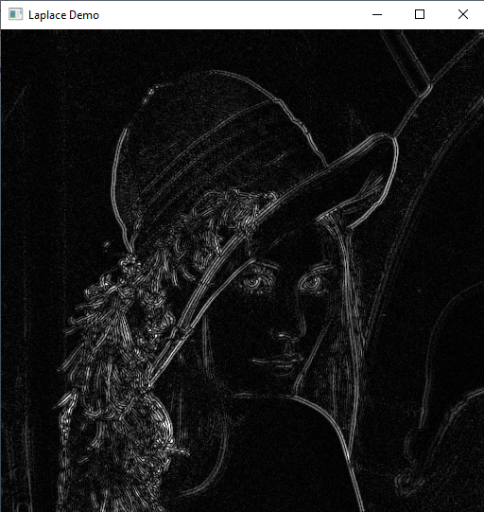

РОБОТА УСПІШНА!

**15) Canny Edge Detector**

from __future__ import print_function  
import cv2 as cv  
import argparse  
max_lowThreshold = 100  
window_name = 'Edge Map'  
title_trackbar = 'Min Threshold:'  
ratio = 3  
kernel_size = 3  
def CannyThreshold(val):  
 low_threshold = val  
 img_blur = cv.blur(src_gray, (3,3))  
 detected_edges = cv.Canny(img_blur, low_threshold, low_threshold*ratio, kernel_size)  
 mask = detected_edges != 0  
 dst = src * (mask[:,:,None].astype(src.dtype))  
 cv.imshow(window_name, dst)  
parser = argparse.ArgumentParser(description='Code for Canny Edge Detector tutorial.')  
parser.add_argument('--input', help='Path to input image.', default='G:/Python/fruits.jpg')  
args = parser.parse_args()  
src = cv.imread(cv.samples.findFile(args.input))  
if src is None:  
 print('Could not open or find the image: ', args.input)  
 exit(0)  
src_gray = cv.cvtColor(src, cv.COLOR_BGR2GRAY)  
cv.namedWindow(window_name)  
cv.createTrackbar(title_trackbar, window_name , 0, max_lowThreshold, CannyThreshold)  
CannyThreshold(0)  
cv.waitKey()

Коли включаєш цей код, саме фото стає трохи чорно-розмитим, а коли ставиш на сотку, то більш чорним.

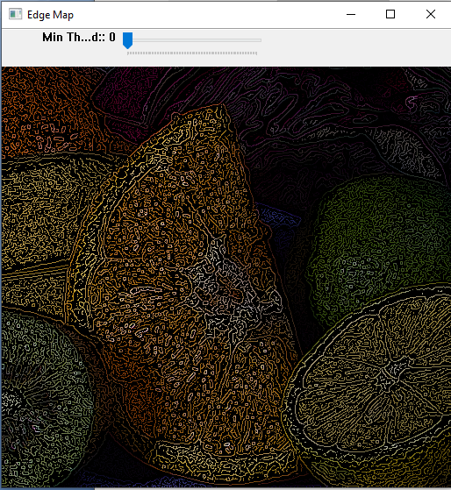

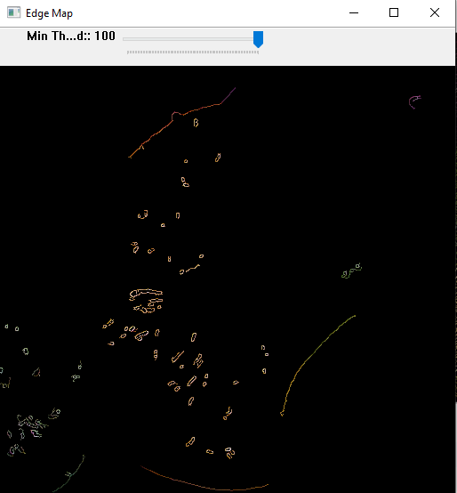

РОБОТА УСПІШНА!

**16) Hough Line Transform**

БУЛО:

import sys  
import math  
import cv2 as cv  
import numpy as np  
  
  
def main(argv):  
 default_file = 'G:/Python/sudoku.png'  
 filename = argv[0] if len(argv) > 0 else default_file  
 # Loads an image  
 src = cv.imread(cv.samples.findFile(filename), cv.IMREAD_GRAYSCALE)  
 # Check if image is loaded fine  
 if src is None:  
 print('Error opening image!')  
 print('Usage: hough_lines.py [image_name -- default ' + default_file + '] \n')  
 return -1  
  
 dst = cv.Canny(src, 50, 200, None, 3)  
  
 # Copy edges to the images that will display the results in BGR  
 cdst = cv.cvtColor(dst, cv.COLOR_GRAY2BGR)  
 cdstP = np.copy(cdst)  
  
 lines = cv.HoughLines(dst, 1, np.pi / 180, 150, None, 0, 0)  
  
 if lines is not None:  
 for i in range(0, len(lines)):  
 rho = lines[i][0][0]  
 theta = lines[i][0][1]  
 a = math.cos(theta)  
 b = math.sin(theta)  
 x0 = a * rho  
 y0 = b * rho  
 pt1 = (int(x0 + 1000 * (-b)), int(y0 + 1000 * (a)))  
 pt2 = (int(x0 - 1000 * (-b)), int(y0 - 1000 * (a)))  
 cv.line(cdst, pt1, pt2, (0, 0, 255), 3, cv.LINE_AA)  
  
 linesP = cv.HoughLinesP(dst, 1, np.pi / 180, 50, None, 50, 10)  
  
 if linesP is not None:  
 for i in range(0, len(linesP)):  
 l = linesP[i][0]  
 cv.line(cdstP, (l[0], l[1]), (l[2], l[3]), (0, 0, 255), 3, cv.LINE_AA)  
  
 cv.imshow("Source", src)  
 cv.imshow("Detected Lines (in red) - Standard Hough Line Transform", cdst)  
 cv.imshow("Detected Lines (in red) - Probabilistic Line Transform", cdstP)  
  
 cv.waitKey()  
 return 0  
  
  
if __name__ == "__main__":  
 main(sys.argv[1:])

РОБОТА НЕУСПІШНА!

СТАЛО:

import sys  
import math  
import cv2 as cv  
import numpy as np  
  
  
def main(argv):  
 default_file = 'G:/Python/sudoku.png'  
 filename = argv[0] if len(argv) > 0 else default_file  
 # Loads an image  
 src = cv.imread(cv.samples.findFile(filename), cv.IMREAD_GRAYSCALE)  
 # Check if image is loaded fine  
 if src is None:  
 print('Error opening image!')  
 print('Usage: hough_lines.py [image_name -- default ' + default_file + '] \n')  
 return -1  
  
 dst = cv.Canny(src, 50, 200, None, 3)  
  
 # Copy edges to the images that will display the results in BGR  
 cdst = cv.cvtColor(dst, cv.COLOR_GRAY2BGR)  
 cdstP = np.copy(cdst)  
  
 lines = cv.HoughLines(dst, 1, np.pi / 180, 150, None, 0, 0)  
  
 if lines is not None:  
 for i in range(0, len(lines)):  
 rho = lines[i][0][0]  
 theta = lines[i][0][1]  
 a = math.cos(theta)  
 b = math.sin(theta)  
 x0 = a * rho  
 y0 = b * rho  
 pt1 = (int(x0 + 1000 * (-b)), int(y0 + 1000 * (a)))  
 pt2 = (int(x0 - 1000 * (-b)), int(y0 - 1000 * (a)))  
 cv.line(cdst, pt1, pt2, (0, 0, 255), 3, cv.LINE_AA)  
  
 linesP = cv.HoughLinesP(dst, 1, np.pi / 180, 50, None, 50, 10)  
  
 if linesP is not None:  
 for i in range(0, len(linesP)):  
 l = linesP[i][0]  
 cv.line(cdstP, (l[0], l[1]), (l[2], l[3]), (0, 0, 255), 3, cv.LINE_AA)  
  
 cv.imshow("Source", src)  
 cv.imshow("Detected Lines (in red) - Standard Hough Line Transform", cdst)  
 cv.imshow("Detected Lines (in red) - Probabilistic Line Transform", cdstP)  
  
 cv.waitKey()  
 return 0  
  
  
if __name__ == "__main__":  
 main(sys.argv[1:])

Єдина проблема була у відступах. Через це виникало помилку!

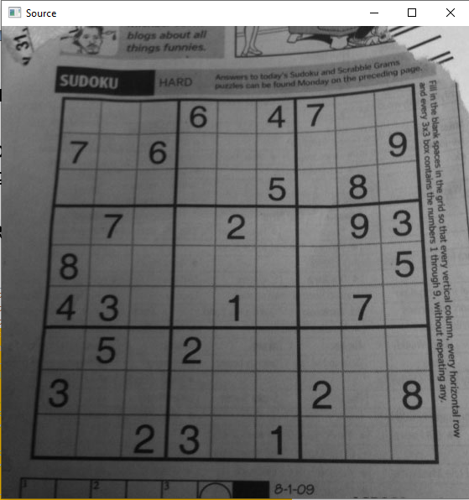

На наступних фото буде видно червоні лінії, тільки в одному фото, вони як прямі, в іншому вони обводжують якісь контури.

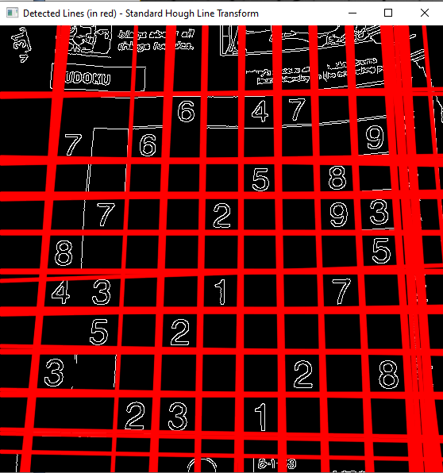

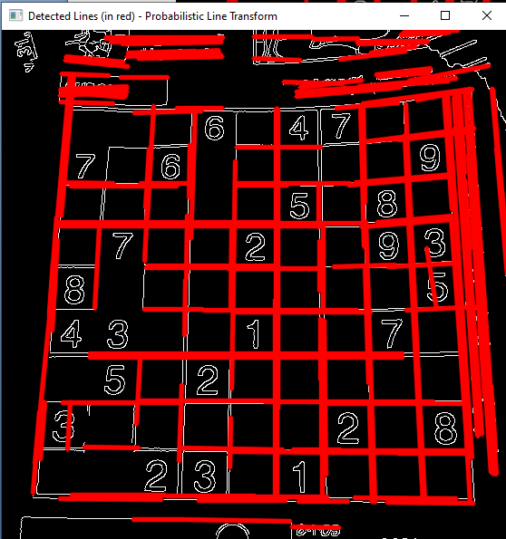

РОБОТА УСПІШНА!

**17) Hough Circle Transform**

БУЛО:

import sys  
import cv2 as cv  
import numpy as np  
  
  
def main(argv):  
 default_file = 'G:/Python/smarties.png'  
 filename = argv[0] if len(argv) > 0 else default_file  
 # Loads an image  
 src = cv.imread(cv.samples.findFile(filename), cv.IMREAD_COLOR)  
 # Check if image is loaded fine  
 if src is None:  
 print('Error opening image!')  
 print('Usage: hough_circle.py [image_name -- default ' + default_file + '] \n')  
 return -1  
  
 gray = cv.cvtColor(src, cv.COLOR_BGR2GRAY)  
  
 gray = cv.medianBlur(gray, 5)  
  
 rows = gray.shape[0]  
 circles = cv.HoughCircles(gray, cv.HOUGH_GRADIENT, 1, rows / 8,  
 param1=100, param2=30,  
 minRadius=1, maxRadius=30)  
  
 if circles is not None:  
 circles = np.uint16(np.around(circles))  
 for i in circles[0, :]:  
 center = (i[0], i[1])  
 # circle center  
 cv.circle(src, center, 1, (0, 100, 100), 3)  
 # circle outline  
 radius = i[2]  
 cv.circle(src, center, radius, (255, 0, 255), 3)  
  
 cv.imshow("detected circles", src)  
 cv.waitKey(0)  
  
 return 0  
  
  
if __name__ == "__main__":  
 main(sys.argv[1:])

РОБОТА НЕУСПІШНА!

СТАЛО:

import sys  
import cv2 as cv  
import numpy as np  
  
  
def main(argv):  
 default_file = 'G:/Python/smarties.png'  
 filename = argv[0] if len(argv) > 0 else default_file  
 # Loads an image  
 src = cv.imread(cv.samples.findFile(filename), cv.IMREAD_COLOR)  
 # Check if image is loaded fine  
 if src is None:  
 print('Error opening image!')  
 print('Usage: hough_circle.py [image_name -- default ' + default_file + '] \n')  
 return -1  
  
 gray = cv.cvtColor(src, cv.COLOR_BGR2GRAY)  
  
 gray = cv.medianBlur(gray, 5)  
  
 rows = gray.shape[0]  
 circles = cv.HoughCircles(gray, cv.HOUGH_GRADIENT, 1, rows / 8,  
 param1=100, param2=30,  
 minRadius=1, maxRadius=30)  
  
 if circles is not None:  
 circles = np.uint16(np.around(circles))  
 for i in circles[0, :]:  
 center = (i[0], i[1])  
 # circle center  
 cv.circle(src, center, 1, (0, 100, 100), 3)  
 # circle outline  
 radius = i[2]  
 cv.circle(src, center, radius, (255, 0, 255), 3)  
  
 cv.imshow("detected circles", src)  
 cv.waitKey(0)  
  
 return 0  
  
  
if __name__ == "__main__":  
 main(sys.argv[1:])

Єдина проблема була у відступах. Через це виникало помилку!

Це завдання схоже з попереднім, тільки вже обводжує коло.

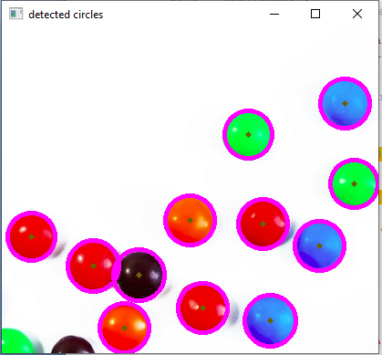

РОБОТА УСПІШНА!

**18) Object detection with Generalized Ballard and Guil Hough Transform**

#include "opencv2/highgui.hpp"  
#include "opencv2/imgproc.hpp"  
using namespace cv;  
using namespace std;  
int main() {  
// load source image and grayscale template  
 samples::addSamplesDataSearchSubDirectory("doc/tutorials/imgproc/generalized_hough_ballard_guil");  
 Mat image = imread(samples::findFile("images/generalized_hough_mini_image.jpg"));  
 Mat templ = imread(samples::findFile("images/generalized_hough_mini_template.jpg"), IMREAD_GRAYSCALE);  
// create grayscale image  
 Mat grayImage;  
 cvtColor(image, grayImage, COLOR_RGB2GRAY);  
// create variable for location, scale and rotation of detected templates  
 vector<Vec4f> positionBallard, positionGuil;  
// template width and height  
 int w = templ.cols;  
 int h = templ.rows;  
// create ballard and set options  
 Ptr<GeneralizedHoughBallard> ballard = createGeneralizedHoughBallard();  
 ballard->setMinDist(10);  
 ballard->setLevels(360);  
 ballard->setDp(2);  
 ballard->setMaxBufferSize(1000);  
 ballard->setVotesThreshold(40);  
 ballard->setCannyLowThresh(30);  
 ballard->setCannyHighThresh(110);  
 ballard->setTemplate(templ);  
// create guil and set options  
 Ptr<GeneralizedHoughGuil> guil = createGeneralizedHoughGuil();  
 guil->setMinDist(10);  
 guil->setLevels(360);  
 guil->setDp(3);  
 guil->setMaxBufferSize(1000);  
 guil->setMinAngle(0);  
 guil->setMaxAngle(360);  
 guil->setAngleStep(1);  
 guil->setAngleThresh(1500);  
 guil->setMinScale(0.5);  
 guil->setMaxScale(2.0);  
 guil->setScaleStep(0.05);  
 guil->setScaleThresh(50);  
 guil->setPosThresh(10);  
 guil->setCannyLowThresh(30);  
 guil->setCannyHighThresh(110);  
 guil->setTemplate(templ);  
// execute ballard detection  
 ballard->detect(grayImage, positionBallard);  
// execute guil detection  
 guil->detect(grayImage, positionGuil);  
// draw ballard  
 for (vector<Vec4f>::iterator iter = positionBallard.begin(); iter != positionBallard.end(); ++iter) {  
 RotatedRect rRect = RotatedRect(Point2f((*iter)[0], (*iter)[1]),  
 Size2f(w * (*iter)[2], h * (*iter)[2]),  
 (*iter)[3]);  
 Point2f vertices[4];  
 rRect.points(vertices);  
 for (int i = 0; i < 4; i++)  
 line(image, vertices[i], vertices[(i + 1) % 4], Scalar(255, 0, 0), 6);  
 }  
// draw guil  
 for (vector<Vec4f>::iterator iter = positionGuil.begin(); iter != positionGuil.end(); ++iter) {  
 RotatedRect rRect = RotatedRect(Point2f((*iter)[0], (*iter)[1]),  
 Size2f(w * (*iter)[2], h * (*iter)[2]),  
 (*iter)[3]);  
 Point2f vertices[4];  
 rRect.points(vertices);  
 for (int i = 0; i < 4; i++)  
 line(image, vertices[i], vertices[(i + 1) % 4], Scalar(0, 255, 0), 2);  
 }  
 imshow("result_img", image);  
 waitKey();  
 return EXIT_SUCCESS;  
}

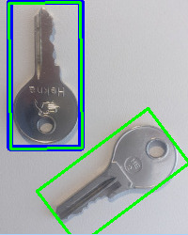

**результат зображення**

Синій прямокутник показує результат [**cv::GeneralizedHoughBallard**](https://docs.opencv.org/4.x/dc/d46/classcv_1_1GeneralizedHoughBallard.html) , а зелені прямокутники – результати [**cv::GeneralizedHoughGuil**](https://docs.opencv.org/4.x/d3/d20/classcv_1_1GeneralizedHoughGuil.html) .

Отримання ідеальних результатів, як у цьому прикладі, малоймовірно, якщо параметри не ідеально адаптовані до зразка. Приклад із менш ідеальними параметрами наведено нижче. Для варіанту Балларда лише центр результату позначено чорною крапкою на цьому зображенні. Прямокутник буде таким же, як на попередньому зображенні.

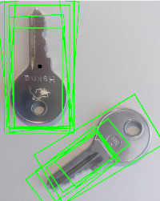

**менш ідеальний результат**

**19) Remapping**

СТАЛО:

from __future__ import print_function  
import cv2 as cv  
import numpy as np  
import argparse  
def update_map(ind, map_x, map_y):  
 if ind == 0:  
 for i in range(map_x.shape[0]):  
 for j in range(map_x.shape[1]):  
 if j > map_x.shape[1]*0.25 and j < map_x.shape[1]*0.75 and i > map_x.shape[0]*0.25 and i < map_x.shape[0]*0.75:  
 map_x[i,j] = 2 * (j-map_x.shape[1]*0.25) + 0.5  
 map_y[i,j] = 2 * (i-map_y.shape[0]*0.25) + 0.5  
 else:  
 map_x[i,j] = 0  
 map_y[i,j] = 0  
 elif ind == 1:  
 for i in range(map_x.shape[0]):  
 map_x[i,:] = [x for x in range(map_x.shape[1])]  
 for j in range(map_y.shape[1]):  
 map_y[:,j] = [map_y.shape[0]-y for y in range(map_y.shape[0])]  
 elif ind == 2:  
 for i in range(map_x.shape[0]):  
 map_x[i,:] = [map_x.shape[1]-x for x in range(map_x.shape[1])]  
 for j in range(map_y.shape[1]):  
 map_y[:,j] = [y for y in range(map_y.shape[0])]  
 elif ind == 3:  
 for i in range(map_x.shape[0]):  
 map_x[i,:] = [map_x.shape[1]-x for x in range(map_x.shape[1])]  
 for j in range(map_y.shape[1]):  
 map_y[:,j] = [map_y.shape[0]-y for y in range(map_y.shape[0])]  
parser = argparse.ArgumentParser(description='Code for Remapping tutorial.')  
parser.add_argument('--input', help='Path to input image.', default='G:/Python/chicky_512.png')  
args = parser.parse_args()  
src = cv.imread(cv.samples.findFile(args.input), cv.IMREAD_COLOR)  
if src is None:  
 print('Could not open or find the image: ', args.input)  
 exit(0)  
map_x = np.zeros((src.shape[0], src.shape[1]), dtype=np.float32)  
map_y = np.zeros((src.shape[0], src.shape[1]), dtype=np.float32)  
window_name = 'Remap demo'  
cv.namedWindow(window_name)  
ind = 0  
while True:  
 update_map(ind, map_x, map_y)  
 ind = (ind + 1) % 4  
 dst = cv.remap(src, map_x, map_y, cv.INTER_LINEAR)  
 cv.imshow(window_name, dst)  
 c = cv.waitKey(1000)  
 if c == 27:  
 break

РОБОТА НЕУСПІШНА!

СТАЛО:

from __future__ import print_function  
import cv2 as cv  
import numpy as np  
import argparse  
def update_map(ind, map_x, map_y):  
 if ind == 0:   
 for i in range(map_x.shape[0]):   
 for j in range(map_x.shape[1]):  
 if j > map_x.shape[1]*0.25 and j < map_x.shape[1]*0.75 and i > map_x.shape[0]*0.25 and i < map_x.shape[0]*0.75:  
 map_x[i,j] = 2 * (j-map_x.shape[1]*0.25) + 0.5  
 map_y[i,j] = 2 * (i-map_y.shape[0]*0.25) + 0.5  
 else:  
 map_x[i,j] = 0  
 map_y[i,j] = 0  
 elif ind == 1:  
 for i in range(map_x.shape[0]):  
 map_x[i,:] = [x for x in range(map_x.shape[1])]  
 for j in range(map_y.shape[1]):  
 map_y[:,j] = [map_y.shape[0]-y for y in range(map_y.shape[0])]  
 elif ind == 2:  
 for i in range(map_x.shape[0]):  
 map_x[i,:] = [map_x.shape[1]-x for x in range(map_x.shape[1])]  
 for j in range(map_y.shape[1]):  
 map_y[:,j] = [y for y in range(map_y.shape[0])]  
 elif ind == 3:  
 for i in range(map_x.shape[0]):  
 map_x[i,:] = [map_x.shape[1]-x for x in range(map_x.shape[1])]  
 for j in range(map_y.shape[1]):  
 map_y[:,j] = [map_y.shape[0]-y for y in range(map_y.shape[0])]  
parser = argparse.ArgumentParser(description='Code for Remapping tutorial.')  
parser.add_argument('--input', help='Path to input image.', default='G:/Python/chicky_512.png')  
args = parser.parse_args()  
src = cv.imread(cv.samples.findFile(args.input), cv.IMREAD_COLOR)  
if src is None:  
 print('Could not open or find the image: ', args.input)  
 exit(0)  
map_x = np.zeros((src.shape[0], src.shape[1]), dtype=np.float32)  
map_y = np.zeros((src.shape[0], src.shape[1]), dtype=np.float32)  
window_name = 'Remap demo'  
cv.namedWindow(window_name)  
ind = 0  
while True:  
 update_map(ind, map_x, map_y)  
 ind = (ind + 1) % 4  
 dst = cv.remap(src, map_x, map_y, cv.INTER_LINEAR)  
 cv.imshow(window_name, dst)  
 c = cv.waitKey(1000)  
 if c == 27: break

Єдина проблема була у відступах. Через це виникало помилку!

Цей код показує етапи обернення фото в процесі роботи.

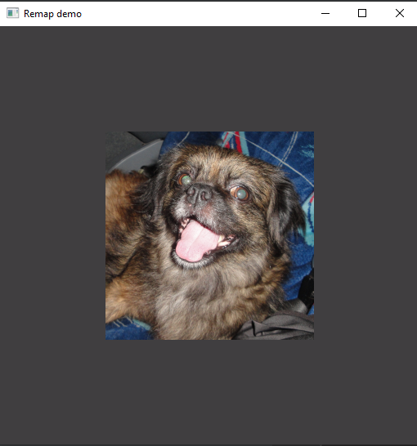

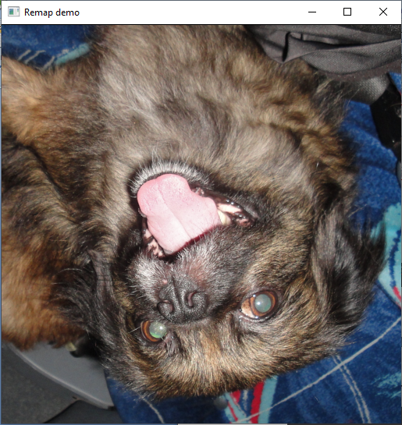

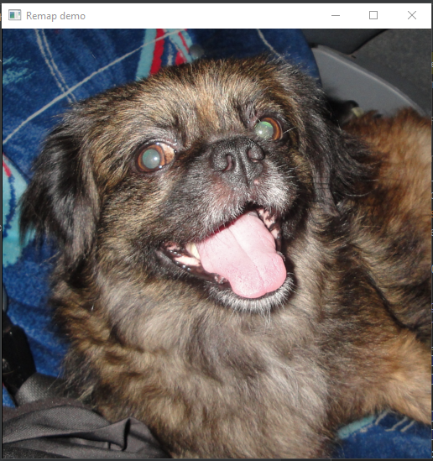

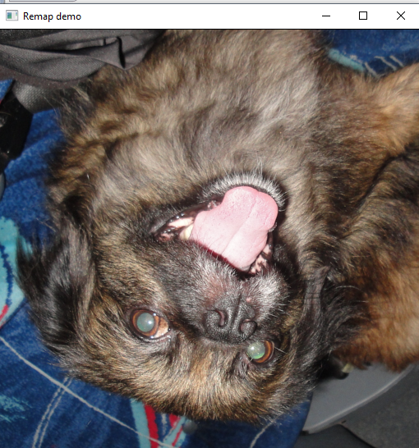

РОБОТА УСПІШНА!

**20) Affine Transformations**

from __future__ import print_function  
import cv2 as cv  
import numpy as np  
import argparse  
parser = argparse.ArgumentParser(description='Code for Affine Transformations tutorial.')  
parser.add_argument('--input', help='Path to input image.', default='G:/Python/lena.jpg')  
args = parser.parse_args()  
src = cv.imread(cv.samples.findFile(args.input))  
if src is None:  
 print('Could not open or find the image:', args.input)  
 exit(0)  
srcTri = np.array( [[0, 0], [src.shape[1] - 1, 0], [0, src.shape[0] - 1]] ).astype(np.float32)  
dstTri = np.array( [[0, src.shape[1]*0.33], [src.shape[1]*0.85, src.shape[0]*0.25], [src.shape[1]*0.15, src.shape[0]*0.7]] ).astype(np.float32)  
warp_mat = cv.getAffineTransform(srcTri, dstTri)  
warp_dst = cv.warpAffine(src, warp_mat, (src.shape[1], src.shape[0]))  
# Rotating the image after Warp  
center = (warp_dst.shape[1]//2, warp_dst.shape[0]//2)  
angle = -50  
scale = 0.6  
rot_mat = cv.getRotationMatrix2D( center, angle, scale )  
warp_rotate_dst = cv.warpAffine(warp_dst, rot_mat, (warp_dst.shape[1], warp_dst.shape[0]))  
cv.imshow('Source image', src)  
cv.imshow('Warp', warp_dst)  
cv.imshow('Warp + Rotate', warp_rotate_dst)  
cv.waitKey()

Сама фотографія стала паралелограмом

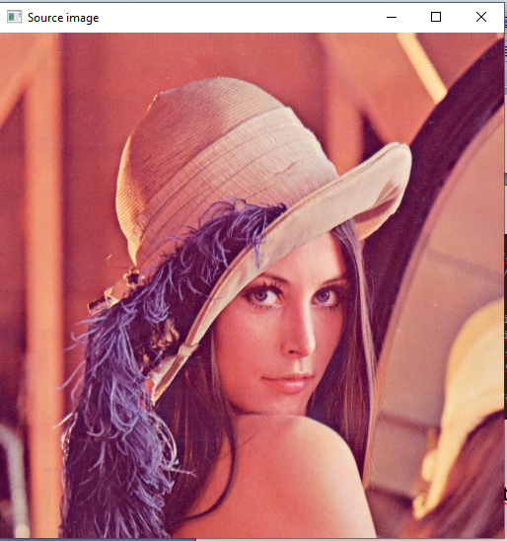

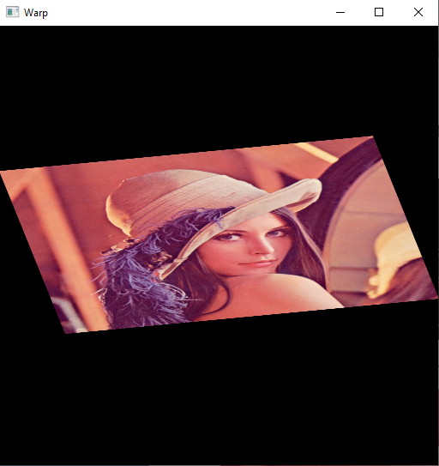

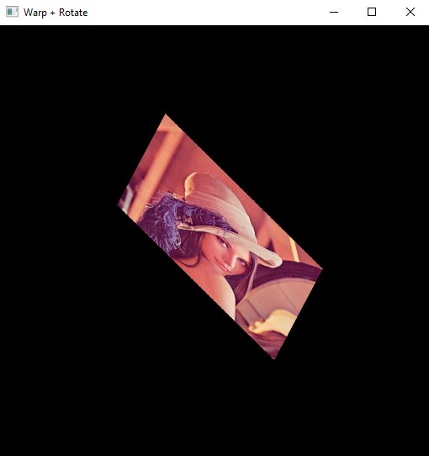

РОБОТА УСПІШНА!

**21) Histogram Equalization**

from __future__ import print_function  
import cv2 as cv  
import argparse  
parser = argparse.ArgumentParser(description='Code for Histogram Equalization tutorial.')  
parser.add_argument('--input', help='Path to input image.', default='G:/Python/lena.jpg')  
args = parser.parse_args()  
src = cv.imread(cv.samples.findFile(args.input))  
if src is None:  
 print('Could not open or find the image:', args.input)  
 exit(0)  
src = cv.cvtColor(src, cv.COLOR_BGR2GRAY)  
dst = cv.equalizeHist(src)  
cv.imshow('Source image', src)  
cv.imshow('Equalized Image', dst)  
cv.waitKey()

Одне із фото стало яскравішим. Але вони двоє чорно-білі.

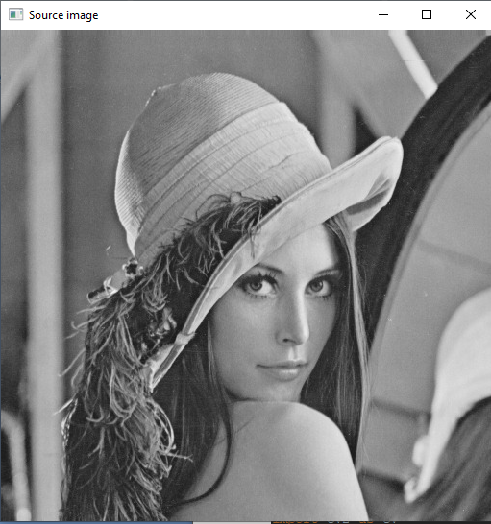

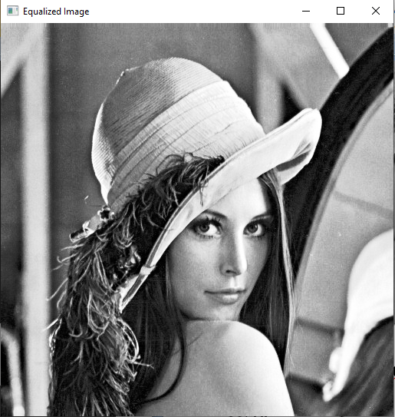

РОБОТА УСПІШНА!

**22) Histogram Calculation**

from __future__ import print_function  
from __future__ import division  
import cv2 as cv  
import numpy as np  
import argparse  
parser = argparse.ArgumentParser(description='Code for Histogram Calculation tutorial.')  
parser.add_argument('--input', help='Path to input image.', default='G:/Python/lena.jpg')  
args = parser.parse_args()  
src = cv.imread(cv.samples.findFile(args.input))  
if src is None:  
 print('Could not open or find the image:', args.input)  
 exit(0)  
bgr_planes = cv.split(src)  
histSize = 256  
histRange = (0, 256) # the upper boundary is exclusive  
accumulate = False  
b_hist = cv.calcHist(bgr_planes, [0], None, [histSize], histRange, accumulate=accumulate)  
g_hist = cv.calcHist(bgr_planes, [1], None, [histSize], histRange, accumulate=accumulate)  
r_hist = cv.calcHist(bgr_planes, [2], None, [histSize], histRange, accumulate=accumulate)  
hist_w = 512  
hist_h = 400  
bin_w = int(round( hist_w/histSize ))  
histImage = np.zeros((hist_h, hist_w, 3), dtype=np.uint8)  
cv.normalize(b_hist, b_hist, alpha=0, beta=hist_h, norm_type=cv.NORM_MINMAX)  
cv.normalize(g_hist, g_hist, alpha=0, beta=hist_h, norm_type=cv.NORM_MINMAX)  
cv.normalize(r_hist, r_hist, alpha=0, beta=hist_h, norm_type=cv.NORM_MINMAX)  
for i in range(1, histSize):  
 cv.line(histImage, ( bin_w*(i-1), hist_h - int(b_hist[i-1]) ),  
 ( bin_w*(i), hist_h - int(b_hist[i]) ),  
 ( 255, 0, 0), thickness=2)  
 cv.line(histImage, ( bin_w*(i-1), hist_h - int(g_hist[i-1]) ),  
 ( bin_w*(i), hist_h - int(g_hist[i]) ),  
 ( 0, 255, 0), thickness=2)  
 cv.line(histImage, ( bin_w*(i-1), hist_h - int(r_hist[i-1]) ),  
 ( bin_w*(i), hist_h - int(r_hist[i]) ),  
 ( 0, 0, 255), thickness=2)  
cv.imshow('Source image', src)  
cv.imshow('calcHist Demo', histImage)  
cv.waitKey()

Визначає діаграму RGB

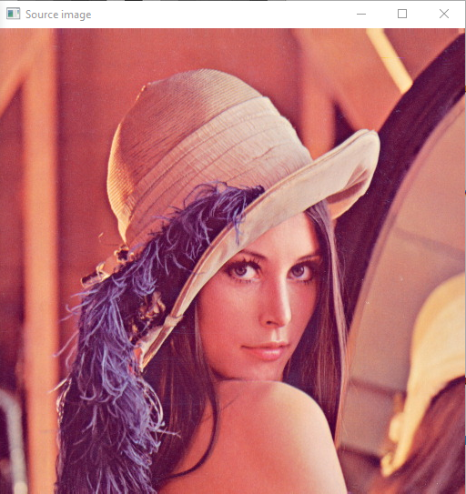

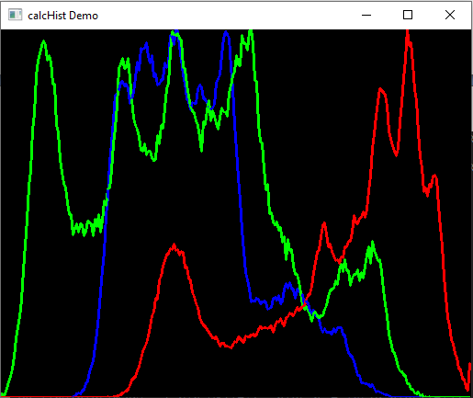

РОБОТА УСПІШНА!

**23) Histogram Comparison**

БУЛО:

from __future__ import print_function  
from __future__ import division  
import cv2 as cv  
import numpy as np  
import argparse  
parser = argparse.ArgumentParser(description='Code for Histogram Comparison tutorial.')  
parser.add_argument('--input1', help='Path to input image 1.')  
parser.add_argument('--input2', help='Path to input image 2.')  
parser.add_argument('--input3', help='Path to input image 3.')  
args = parser.parse_args()  
src_base = cv.imread(args.input1)  
src_test1 = cv.imread(args.input2)  
src_test2 = cv.imread(args.input3)  
if src_base is None or src_test1 is None or src_test2 is None:  
 print('Could not open or find the images!')  
 exit(0)  
hsv_base = cv.cvtColor(src_base, cv.COLOR_BGR2HSV)  
hsv_test1 = cv.cvtColor(src_test1, cv.COLOR_BGR2HSV)  
hsv_test2 = cv.cvtColor(src_test2, cv.COLOR_BGR2HSV)  
hsv_half_down = hsv_base[hsv_base.shape[0]//2:,:]  
h_bins = 50  
s_bins = 60  
histSize = [h_bins, s_bins]  
# hue varies from 0 to 179, saturation from 0 to 255  
h_ranges = [0, 180]  
s_ranges = [0, 256]  
ranges = h_ranges + s_ranges # concat lists  
# Use the 0-th and 1-st channels  
channels = [0, 1]  
hist_base = cv.calcHist([hsv_base], channels, None, histSize, ranges, accumulate=False)  
cv.normalize(hist_base, hist_base, alpha=0, beta=1, norm_type=cv.NORM_MINMAX)  
hist_half_down = cv.calcHist([hsv_half_down], channels, None, histSize, ranges, accumulate=False)  
cv.normalize(hist_half_down, hist_half_down, alpha=0, beta=1, norm_type=cv.NORM_MINMAX)  
hist_test1 = cv.calcHist([hsv_test1], channels, None, histSize, ranges, accumulate=False)  
cv.normalize(hist_test1, hist_test1, alpha=0, beta=1, norm_type=cv.NORM_MINMAX)  
hist_test2 = cv.calcHist([hsv_test2], channels, None, histSize, ranges, accumulate=False)  
cv.normalize(hist_test2, hist_test2, alpha=0, beta=1, norm_type=cv.NORM_MINMAX)  
for compare_method in range(4):  
 base_base = cv.compareHist(hist_base, hist_base, compare_method)  
 base_half = cv.compareHist(hist_base, hist_half_down, compare_method)  
 base_test1 = cv.compareHist(hist_base, hist_test1, compare_method)  
 base_test2 = cv.compareHist(hist_base, hist_test2, compare_method)  
 print('Method:', compare_method, 'Perfect, Base-Half, Base-Test(1), Base-Test(2) :',\  
 base_base, '/', base_half, '/', base_test1, '/', base_test2)

РОБОТА НЕУСПІШНА!

СТАЛО:

from __future__ import print_function  
from __future__ import division  
import cv2 as cv  
import numpy as np  
#import argparse  
#parser = argparse.ArgumentParser(description='Code for Histogram Comparison tutorial.')  
#parser.add_argument('--input1', help='Path to input image 1.')  
#parser.add_argument('--input2', help='Path to input image 2.')  
#parser.add_argument('--input3', help='Path to input image 3.')  
#args = parser.parse_args()  
src_base = cv.imread("G:/Python/baboon.jpg")  
src_test1 = cv.imread("G:/Python/cards.png")  
src_test2 = cv.imread("G:/Python/lena.jpg")  
if src_base is None or src_test1 is None or src_test2 is None:  
 print('Could not open or find the images!')  
 exit(0)  
hsv_base = cv.cvtColor(src_base, cv.COLOR_BGR2HSV)  
hsv_test1 = cv.cvtColor(src_test1, cv.COLOR_BGR2HSV)  
hsv_test2 = cv.cvtColor(src_test2, cv.COLOR_BGR2HSV)  
hsv_half_down = hsv_base[hsv_base.shape[0]//2:,:]  
h_bins = 50  
s_bins = 60  
histSize = [h_bins, s_bins]  
# hue varies from 0 to 179, saturation from 0 to 255  
h_ranges = [0, 180]  
s_ranges = [0, 256]  
ranges = h_ranges + s_ranges # concat lists  
# Use the 0-th and 1-st channels  
channels = [0, 1]  
hist_base = cv.calcHist([hsv_base], channels, None, histSize, ranges, accumulate=False)  
cv.normalize(hist_base, hist_base, alpha=0, beta=1, norm_type=cv.NORM_MINMAX)  
hist_half_down = cv.calcHist([hsv_half_down], channels, None, histSize, ranges, accumulate=False)  
cv.normalize(hist_half_down, hist_half_down, alpha=0, beta=1, norm_type=cv.NORM_MINMAX)  
hist_test1 = cv.calcHist([hsv_test1], channels, None, histSize, ranges, accumulate=False)  
cv.normalize(hist_test1, hist_test1, alpha=0, beta=1, norm_type=cv.NORM_MINMAX)  
hist_test2 = cv.calcHist([hsv_test2], channels, None, histSize, ranges, accumulate=False)  
cv.normalize(hist_test2, hist_test2, alpha=0, beta=1, norm_type=cv.NORM_MINMAX)  
for compare_method in range(4):  
 base_base = cv.compareHist(hist_base, hist_base, compare_method)  
 base_half = cv.compareHist(hist_base, hist_half_down, compare_method)  
 base_test1 = cv.compareHist(hist_base, hist_test1, compare_method)  
 base_test2 = cv.compareHist(hist_base, hist_test2, compare_method)  
 print('Method:', compare_method, 'Perfect, Base-Half, Base-Test(1), Base-Test(2) :',\  
 base_base, '/', base_half, '/', base_test1, '/', base_test2)

Якраз тут треба було працювати з argv. Звісно, не вдалось але зробили по іншому. Це завдання показує порівнюємо гістограму основного зображення з самою собою. Крім того, у порівнянні з гістограмою половини основного зображення, воно повинно мати високу відповідність, оскільки обидва з того самого джерела.



РОБОТА УСПІШНА!

**24) Back Projection**

from __future__ import print_function  
from __future__ import division  
import cv2 as cv  
import numpy as np  
import argparse  
  
  
def Hist_and_Backproj(val):  
 bins = val  
 histSize = max(bins, 2)  
 ranges = [0, 180] # hue_range  
  
 hist = cv.calcHist([hue], [0], None, [histSize], ranges, accumulate=False)  
 cv.normalize(hist, hist, alpha=0, beta=255, norm_type=cv.NORM_MINMAX)  
  
 backproj = cv.calcBackProject([hue], [0], hist, ranges, scale=1)  
  
 cv.imshow('BackProj', backproj)  
  
 w = 400  
 h = 400  
 bin_w = int(round(w / histSize))  
 histImg = np.zeros((h, w, 3), dtype=np.uint8)  
 for i in range(bins):  
 cv.rectangle(histImg, (i * bin_w, h), ((i + 1) * bin_w, h - int(np.round(hist[i] * h / 255.0))), (0, 0, 255),  
 cv.FILLED)  
 cv.imshow('Histogram', histImg)  
  
  
parser = argparse.ArgumentParser(description='Code for Back Projection tutorial.')  
parser.add_argument('--input', help='Path to input image.', default='G:/Python/home.jpg')  
args = parser.parse_args()  
src = cv.imread(cv.samples.findFile(args.input))  
if src is None:  
 print('Could not open or find the image:', args.input)  
 exit(0)  
hsv = cv.cvtColor(src, cv.COLOR_BGR2HSV)  
ch = (0, 0)  
hue = np.empty(hsv.shape, hsv.dtype)  
cv.mixChannels([hsv], [hue], ch)  
window_image = 'Source image'  
cv.namedWindow(window_image)  
bins = 25  
cv.createTrackbar('* Hue bins: ', window_image, bins, 180, Hist_and_Backproj)  
Hist_and_Backproj(bins)  
cv.imshow(window_image, src)  
cv.waitKey()

Робить фото розмитим і чорно-білим, а ще показує діаграму цієї дії.

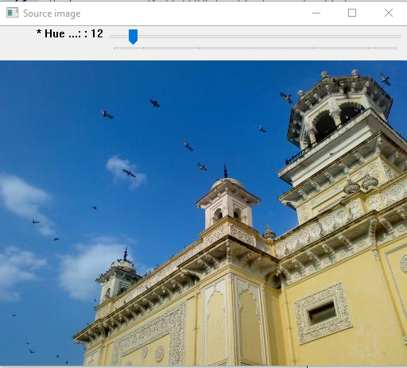

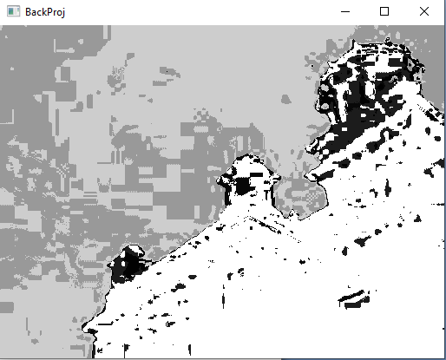

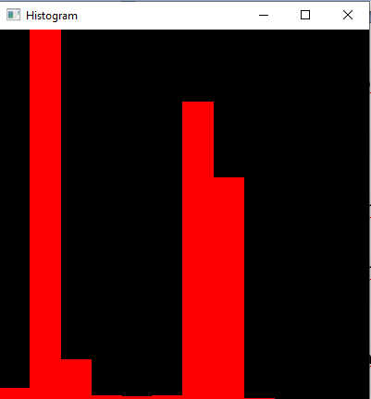

РОБОТА УСПІШНА!

**25) Template Matching**

from __future__ import print_function  
import sys  
import cv2 as cv  
  
use_mask = False  
img = None  
templ = None  
mask = None  
image_window = "Source Image"  
result_window = "Result window"  
match_method = 0  
max_Trackbar = 5  
  
  
def main(argv):  
 if (len(sys.argv) < 3):  
 print('Not enough parameters')  
 print('Usage:\nmatch_template_demo.py <image_name> <template_name> [<mask_name>]')  
 return -1  
  
 global img  
 global templ  
 img = cv.imread(sys.argv[1], cv.IMREAD_COLOR)  
 templ = cv.imread(sys.argv[2], cv.IMREAD_COLOR)  
 if (len(sys.argv) > 3):  
 global use_mask  
 use_mask = True  
 global mask  
 mask = cv.imread(sys.argv[3], cv.IMREAD_COLOR)  
 if ((img is None) or (templ is None) or (use_mask and (mask is None))):  
 print('Can\'t read one of the images')  
 return -1  
  
 cv.namedWindow(image_window, cv.WINDOW_AUTOSIZE)  
 cv.namedWindow(result_window, cv.WINDOW_AUTOSIZE)  
  
 trackbar_label = 'Method: \n 0: SQDIFF \n 1: SQDIFF NORMED \n 2: TM CCORR \n 3: TM CCORR NORMED \n 4: TM COEFF \n 5: TM COEFF NORMED'  
 cv.createTrackbar(trackbar_label, image_window, match_method, max_Trackbar, MatchingMethod)  
  
 MatchingMethod(match_method)  
  
 cv.waitKey(0)  
 return 0  
  
  
def MatchingMethod(param):  
 global match_method  
 match_method = param  
  
 img_display = img.copy()  
  
 method_accepts_mask = (cv.TM_SQDIFF == match_method or match_method == cv.TM_CCORR_NORMED)  
 if (use_mask and method_accepts_mask):  
 result = cv.matchTemplate(img, templ, match_method, None, mask)  
 else:  
 result = cv.matchTemplate(img, templ, match_method)  
  
 cv.normalize(result, result, 0, 1, cv.NORM_MINMAX, -1)  
  
 _minVal, _maxVal, minLoc, maxLoc = cv.minMaxLoc(result, None)  
  
 if (match_method == cv.TM_SQDIFF or match_method == cv.TM_SQDIFF_NORMED):  
 matchLoc = minLoc  
 else:  
 matchLoc = maxLoc  
  
 cv.rectangle(img_display, matchLoc, (matchLoc[0] + templ.shape[0], matchLoc[1] + templ.shape[1]), (0, 0, 0), 2, 8,  
 0)  
 cv.rectangle(result, matchLoc, (matchLoc[0] + templ.shape[0], matchLoc[1] + templ.shape[1]), (0, 0, 0), 2, 8, 0)  
 cv.imshow(image_window, img_display)  
 cv.imshow(result_window, result)  
  
 pass  
  
  
if __name__ == "__main__":  
 main(sys.argv[1:])

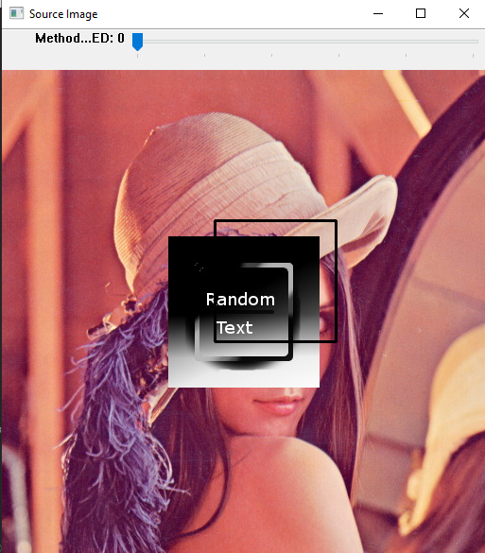

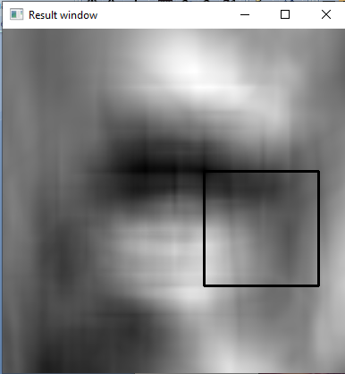

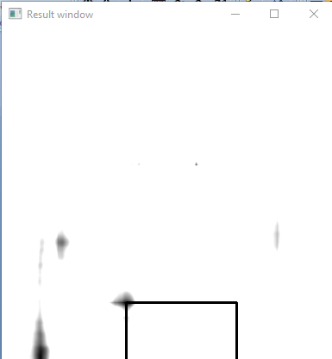

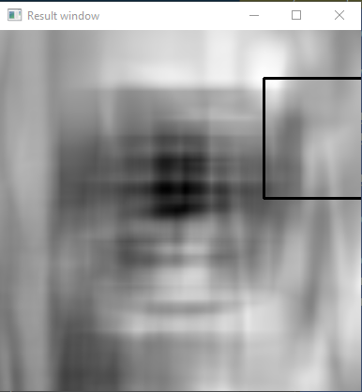

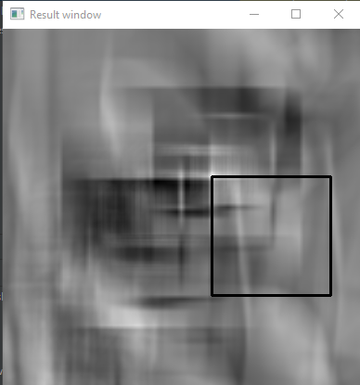

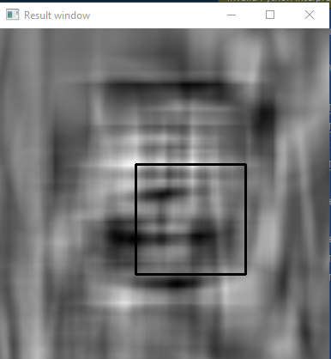

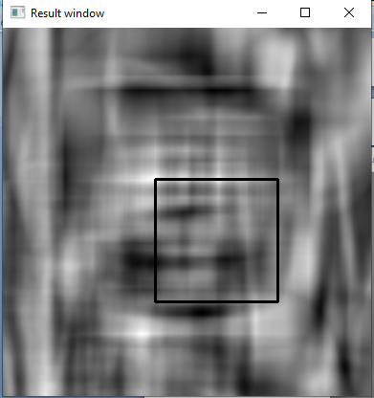

РОБОТА УСПІШНА!

**26) Finding contours in your image**

БУЛО:

from __future__ import print_function  
import cv2 as cv  
import numpy as np  
import argparse  
import random as rng  
rng.seed(12345)  
def thresh_callback(val):  
 threshold = val  
 # Detect edges using Canny  
 canny_output = cv.Canny(src_gray, threshold, threshold * 2)  
 # Find contours  
 contours, hierarchy = cv.findContours(canny_output, cv.RETR_TREE, cv.CHAIN_APPROX_SIMPLE)  
 # Draw contours  
 drawing = np.zeros((canny_output.shape[0], canny_output.shape[1], 3), dtype=np.uint8)  
 for i in range(len(contours)):  
 color = (rng.randint(0,256), rng.randint(0,256), rng.randint(0,256))  
 cv.drawContours(drawing, contours, i, color, 2, cv.LINE_8, hierarchy, 0)  
 # Show in a window  
 cv.imshow('Contours', drawing)  
# Load source image  
parser = argparse.ArgumentParser(description='Code for Finding contours in your image tutorial.')  
parser.add_argument('--input', help='Path to input image.', default='HappyFish.jpg')  
args = parser.parse_args()  
src = cv.imread(cv.samples.findFile(args.input))  
if src is None:  
 print('Could not open or find the image:', args.input)  
 exit(0)  
# Convert image to gray and blur it  
src_gray = cv.cvtColor(src, cv.COLOR_BGR2GRAY)  
src_gray = cv.blur(src_gray, (3,3))  
# Create Window  
source_window = 'Source'  
cv.namedWindow(source_window)  
cv.imshow(source_window, src)  
max_thresh = 255  
thresh = 100 # initial threshold  
cv.createTrackbar('Canny Thresh:', source_window, thresh, max_thresh, thresh_callback)  
thresh_callback(thresh)  
cv.waitKey()

РОБОТА НЕУСПІШНА!

СТАЛО:

from __future__ import print_function  
import cv2 as cv  
import numpy as np  
import argparse  
import random as rng  
rng.seed(12345)  
def thresh_callback(val):  
 threshold = val  
 # Detect edges using Canny  
 canny_output = cv.Canny(src_gray, threshold, threshold * 2)  
 # Find contours  
 contours, hierarchy = cv.findContours(canny_output, cv.RETR_TREE, cv.CHAIN_APPROX_SIMPLE)  
 # Draw contours  
 drawing = np.zeros((canny_output.shape[0], canny_output.shape[1], 3), dtype=np.uint8)  
 for i in range(len(contours)):  
 color = (rng.randint(0,256), rng.randint(0,256), rng.randint(0,256))  
 cv.drawContours(drawing, contours, i, color, 2, cv.LINE_8, hierarchy, 0)  
 # Show in a window  
 cv.imshow('Contours', drawing)  
# Load source image  
parser = argparse.ArgumentParser(description='Code for Finding contours in your image tutorial.')  
parser.add_argument('--input', help='Path to input image.', default='G:/Python/HappyFish.jpg')  
args = parser.parse_args()  
src = cv.imread(cv.samples.findFile(args.input))  
if src is None:  
 print('Could not open or find the image:', args.input)  
 exit(0)  
# Convert image to gray and blur it  
src_gray = cv.cvtColor(src, cv.COLOR_BGR2GRAY)  
src_gray = cv.blur(src_gray, (3,3))  
# Create Window  
source_window = 'Source'  
cv.namedWindow(source_window)  
cv.imshow(source_window, src)  
max_thresh = 255  
thresh = 100 # initial threshold  
cv.createTrackbar('Canny Thresh:', source_window, thresh, max_thresh, thresh_callback)  
thresh_callback(thresh)  
cv.waitKey()

Єдина проблема була у відступах. Через це виникало помилку!

Воно обводить різнокольорові контури, але чим більшу має цифру Canny, тим менше контурів обведених.

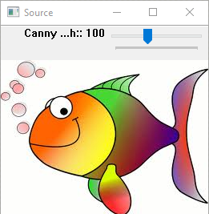

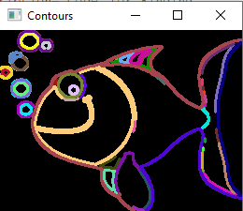

РОБОТА УСПІШНА!

**27) Convex Hull**

БУЛО:

from __future__ import print_function  
import cv2 as cv  
import numpy as np  
import argparse  
import random as rng  
rng.seed(12345)  
def thresh_callback(val):  
 threshold = val  
 # Detect edges using Canny  
 canny_output = cv.Canny(src_gray, threshold, threshold * 2)  
 # Find contours  
 contours, _ = cv.findContours(canny_output, cv.RETR_TREE, cv.CHAIN_APPROX_SIMPLE)  
 # Find the convex hull object for each contour  
 hull_list = []  
 for i in range(len(contours)):  
 hull = cv.convexHull(contours[i])  
 hull_list.append(hull)  
 # Draw contours + hull results  
 drawing = np.zeros((canny_output.shape[0], canny_output.shape[1], 3), dtype=np.uint8)  
 for i in range(len(contours)):  
 color = (rng.randint(0,256), rng.randint(0,256), rng.randint(0,256))  
 cv.drawContours(drawing, contours, i, color)  
 cv.drawContours(drawing, hull_list, i, color)  
 # Show in a window  
 cv.imshow('Contours', drawing)  
# Load source image  
parser = argparse.ArgumentParser(description='Code for Convex Hull tutorial.')  
parser.add_argument('--input', help='Path to input image.', default='G:/Python/stuff.jpg')  
args = parser.parse_args()  
src = cv.imread(cv.samples.findFile(args.input))  
if src is None:  
 print('Could not open or find the image:', args.input)  
 exit(0)  
# Convert image to gray and blur it  
src_gray = cv.cvtColor(src, cv.COLOR_BGR2GRAY)  
src_gray = cv.blur(src_gray, (3,3))  
# Create Window  
source_window = 'Source'  
cv.namedWindow(source_window)  
cv.imshow(source_window, src)  
max_thresh = 255  
thresh = 100 # initial threshold  
cv.createTrackbar('Canny thresh:', source_window, thresh, max_thresh, thresh_callback)  
thresh_callback(thresh)  
cv.waitKey()

РОБОТА НЕУСПІШНА!

СТАЛО:

from __future__ import print_function  
import cv2 as cv  
import numpy as np  
import argparse  
import random as rng  
rng.seed(12345)  
def thresh_callback(val):  
 threshold = val  
 # Detect edges using Canny  
 canny_output = cv.Canny(src_gray, threshold, threshold * 2)  
 # Find contours  
 contours, _ = cv.findContours(canny_output, cv.RETR_TREE, cv.CHAIN_APPROX_SIMPLE)  
 # Find the convex hull object for each contour  
 hull_list = []  
 for i in range(len(contours)):  
 hull = cv.convexHull(contours[i])  
 hull_list.append(hull)  
 # Draw contours + hull results  
 drawing = np.zeros((canny_output.shape[0], canny_output.shape[1], 3), dtype=np.uint8)  
 for i in range(len(contours)):  
 color = (rng.randint(0,256), rng.randint(0,256), rng.randint(0,256))  
 cv.drawContours(drawing, contours, i, color)  
 cv.drawContours(drawing, hull_list, i, color)  
 # Show in a window  
 cv.imshow('Contours', drawing)  
# Load source image  
parser = argparse.ArgumentParser(description='Code for Convex Hull tutorial.')  
parser.add_argument('--input', help='Path to input image.', default='G:/Python/stuff.jpg')  
args = parser.parse_args()  
src = cv.imread(cv.samples.findFile(args.input))  
if src is None:  
 print('Could not open or find the image:', args.input)  
 exit(0)  
# Convert image to gray and blur it  
src_gray = cv.cvtColor(src, cv.COLOR_BGR2GRAY)  
src_gray = cv.blur(src_gray, (3,3))  
# Create Window  
source_window = 'Source'  
cv.namedWindow(source_window)  
cv.imshow(source_window, src)  
max_thresh = 255  
thresh = 100 # initial threshold  
cv.createTrackbar('Canny thresh:', source_window, thresh, max_thresh, thresh_callback)  
thresh_callback(thresh)  
cv.waitKey()

Єдина проблема була у відступах. Через це виникало помилку!

Воно те саме, що попереднє, тільки в них товщина менша.

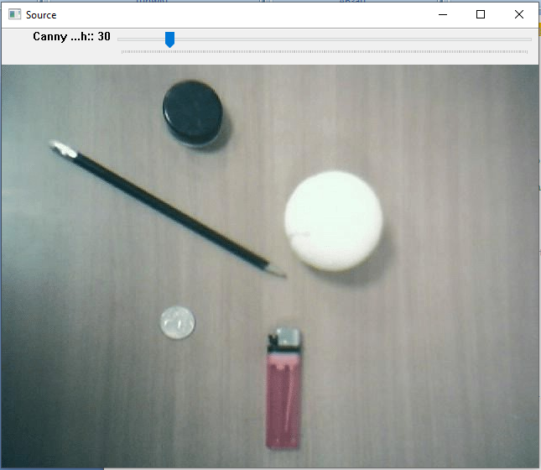

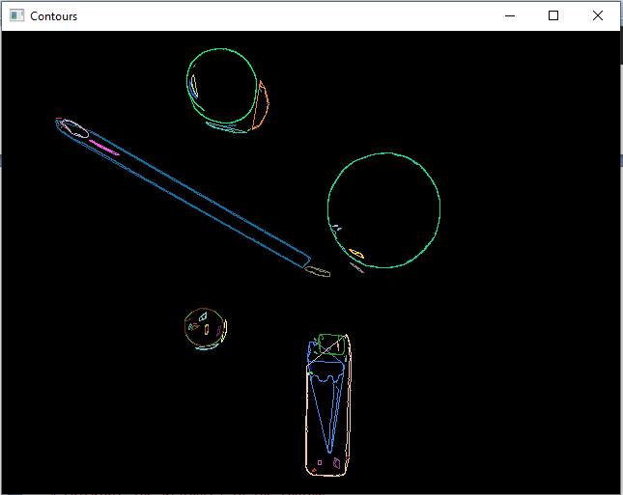

РОБОТА УСПІШНА!

**28) Creating Bounding boxes and circles for contours**

from __future__ import print_function  
import cv2 as cv  
import numpy as np  
import argparse  
import random as rng  
  
rng.seed(12345)  
  
  
def thresh_callback(val):  
 threshold = val  
  
 canny_output = cv.Canny(src_gray, threshold, threshold * 2)  
  
 contours, _ = cv.findContours(canny_output, cv.RETR_TREE, cv.CHAIN_APPROX_SIMPLE)  
  
 contours_poly = [None] * len(contours)  
 boundRect = [None] * len(contours)  
 centers = [None] * len(contours)  
 radius = [None] * len(contours)  
 for i, c in enumerate(contours):  
 contours_poly[i] = cv.approxPolyDP(c, 3, True)  
 boundRect[i] = cv.boundingRect(contours_poly[i])  
 centers[i], radius[i] = cv.minEnclosingCircle(contours_poly[i])  
  
 drawing = np.zeros((canny_output.shape[0], canny_output.shape[1], 3), dtype=np.uint8)  
  
 for i in range(len(contours)):  
 color = (rng.randint(0, 256), rng.randint(0, 256), rng.randint(0, 256))  
 cv.drawContours(drawing, contours_poly, i, color)  
 cv.rectangle(drawing, (int(boundRect[i][0]), int(boundRect[i][1])), \  
 (int(boundRect[i][0] + boundRect[i][2]), int(boundRect[i][1] + boundRect[i][3])), color, 2)  
 cv.circle(drawing, (int(centers[i][0]), int(centers[i][1])), int(radius[i]), color, 2)  
  
 cv.imshow('Contours', drawing)  
  
  
parser = argparse.ArgumentParser(description='Code for Creating Bounding boxes and circles for contours tutorial.')  
parser.add_argument('--input', help='Path to input image.', default='G:/Python/stuff.jpg')  
args = parser.parse_args()  
src = cv.imread(cv.samples.findFile(args.input))  
if src is None:  
 print('Could not open or find the image:', args.input)  
 exit(0)  
# Convert image to gray and blur it  
src_gray = cv.cvtColor(src, cv.COLOR_BGR2GRAY)  
src_gray = cv.blur(src_gray, (3, 3))  
source_window = 'Source'  
cv.namedWindow(source_window)  
cv.imshow(source_window, src)  
max_thresh = 255  
thresh = 100 # initial threshold  
cv.createTrackbar('Canny thresh:', source_window, thresh, max_thresh, thresh_callback)  
thresh_callback(thresh)  
cv.waitKey()

Робить контур із фото, а також навколо нього описаний прямокутник.

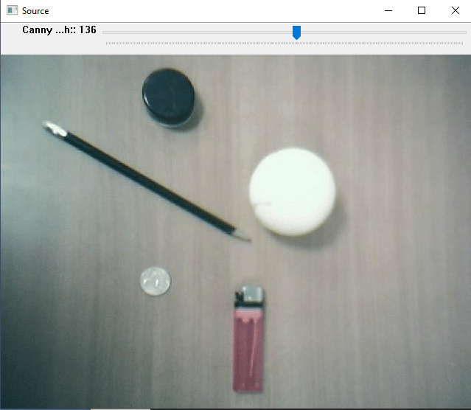

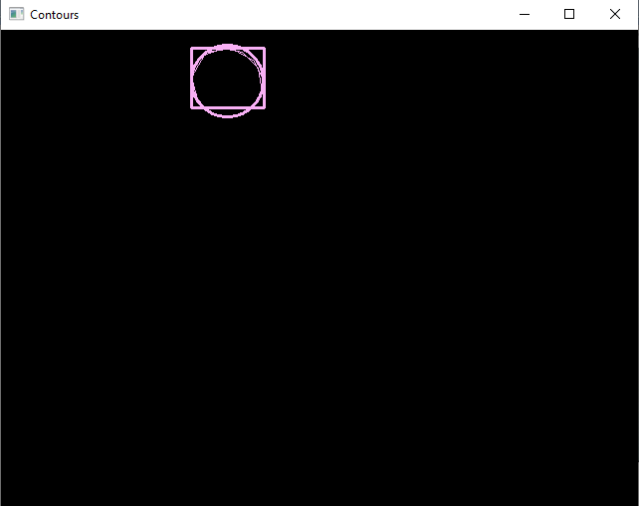

РОБОТА УСПІШНА!

**29) Creating Bounding rotated boxes and ellipses for contours**

from __future__ import print_function  
import cv2 as cv  
import numpy as np  
import argparse  
import random as rng  
  
rng.seed(12345)  
  
  
def thresh_callback(val):  
 threshold = val  
  
 canny_output = cv.Canny(src_gray, threshold, threshold * 2)  
  
 contours, _ = cv.findContours(canny_output, cv.RETR_TREE, cv.CHAIN_APPROX_SIMPLE)  
  
 # Find the rotated rectangles and ellipses for each contour  
 minRect = [None] * len(contours)  
 minEllipse = [None] * len(contours)  
 for i, c in enumerate(contours):  
 minRect[i] = cv.minAreaRect(c)  
 if c.shape[0] > 5:  
 minEllipse[i] = cv.fitEllipse(c)  
 # Draw contours + rotated rects + ellipses  
  
 drawing = np.zeros((canny_output.shape[0], canny_output.shape[1], 3), dtype=np.uint8)  
  
 for i, c in enumerate(contours):  
 color = (rng.randint(0, 256), rng.randint(0, 256), rng.randint(0, 256))  
 # contour  
 cv.drawContours(drawing, contours, i, color)  
 # ellipse  
 if c.shape[0] > 5:  
 cv.ellipse(drawing, minEllipse[i], color, 2)  
 # rotated rectangle  
 box = cv.boxPoints(minRect[i])  
 box = np.intp(box) # np.intp: Integer used for indexing (same as C ssize_t; normally either int32 or int64)  
 cv.drawContours(drawing, [box], 0, color)  
  
 cv.imshow('Contours', drawing)  
  
  
parser = argparse.ArgumentParser(  
 description='Code for Creating Bounding rotated boxes and ellipses for contours tutorial.')  
parser.add_argument('--input', help='Path to input image.', default='G:/Python/stuff.jpg')  
args = parser.parse_args()  
src = cv.imread(cv.samples.findFile(args.input))  
if src is None:  
 print('Could not open or find the image:', args.input)  
 exit(0)  
# Convert image to gray and blur it  
src_gray = cv.cvtColor(src, cv.COLOR_BGR2GRAY)  
src_gray = cv.blur(src_gray, (3, 3))  
source_window = 'Source'  
cv.namedWindow(source_window)  
cv.imshow(source_window, src)  
max_thresh = 255  
thresh = 100 # initial threshold  
cv.createTrackbar('Canny Thresh:', source_window, thresh, max_thresh, thresh_callback)  
thresh_callback(thresh)  
cv.waitKey()

Те саме, тільки перевертає описаний прямокутник.

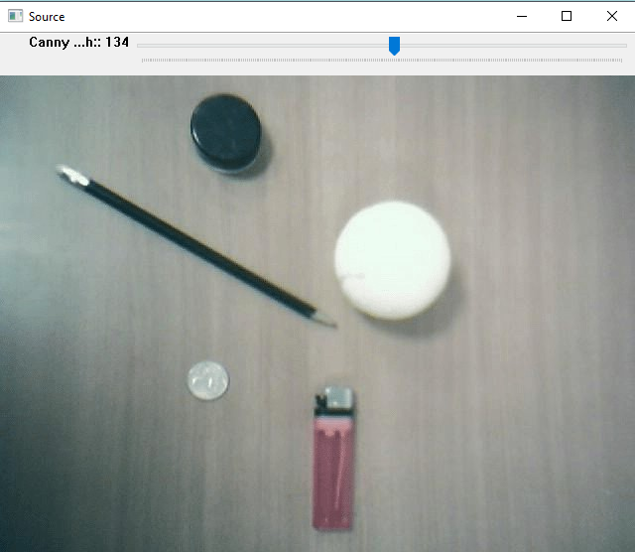

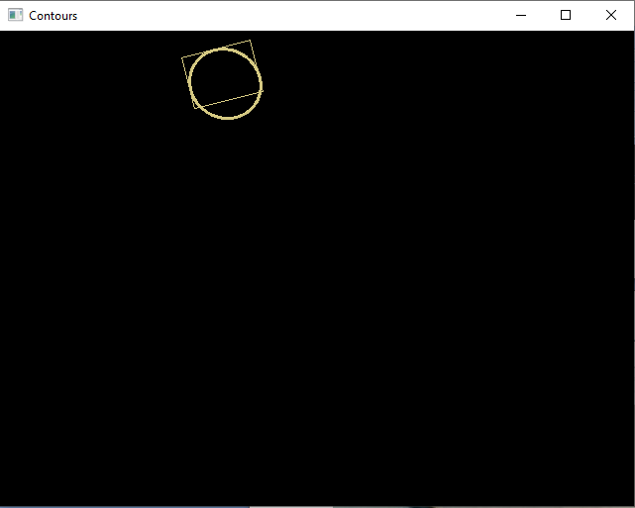

РОБОТА УСПІШНА!

**30) Image Moments**

БУЛО:

from __future__ import print_function  
from __future__ import division  
import cv2 as cv  
import numpy as np  
import argparse  
import random as rng  
  
rng.seed(12345)  
  
  
def thresh_callback(val):  
 threshold = val  
  
 canny_output = cv.Canny(src_gray, threshold, threshold * 2)  
  
 contours, _ = cv.findContours(canny_output, cv.RETR_TREE, cv.CHAIN_APPROX_SIMPLE)  
  
 # Get the moments  
 mu = [None] * len(contours)  
 for i in range(len(contours)):  
 mu[i] = cv.moments(contours[i])  
 # Get the mass centers  
 mc = [None] * len(contours)  
 for i in range(len(contours)):  
 # add 1e-5 to avoid division by zero  
 mc[i] = (mu[i]['m10'] / (mu[i]['m00'] + 1e-5), mu[i]['m01'] / (mu[i]['m00'] + 1e-5))  
 # Draw contours  
  
 drawing = np.zeros((canny_output.shape[0], canny_output.shape[1], 3), dtype=np.uint8)  
  
 for i in range(len(contours)):  
 color = (rng.randint(0, 256), rng.randint(0, 256), rng.randint(0, 256))  
 cv.drawContours(drawing, contours, i, color, 2)  
 cv.circle(drawing, (int(mc[i][0]), int(mc[i][1])), 4, color, -1)  
  
 cv.imshow('Contours', drawing)  
  
 # Calculate the area with the moments 00 and compare with the result of the OpenCV function  
 for i in range(len(contours)):  
 print(' * Contour[%d] - Area (M_00) = %.2f - Area OpenCV: %.2f - Length: %.2f' % (  
 i, mu[i]['m00'], cv.contourArea(contours[i]), cv.arcLength(contours[i], True)))  
  
  
parser = argparse.ArgumentParser(description='Code for Image Moments tutorial.')  
parser.add_argument('--input', help='Path to input image.', default='G:/Python/stuff.jpg')  
args = parser.parse_args()  
src = cv.imread(cv.samples.findFile(args.input))  
if src is None:  
 print('Could not open or find the image:', args.input)  
 exit(0)  
# Convert image to gray and blur it  
src_gray = cv.cvtColor(src, cv.COLOR_BGR2GRAY)  
src_gray = cv.blur(src_gray, (3, 3))  
source_window = 'Source'  
cv.namedWindow(source_window)  
cv.imshow(source_window, src)  
max_thresh = 255  
thresh = 100 # initial threshold  
cv.createTrackbar('Canny Thresh:', source_window, thresh, max_thresh, thresh_callback)  
thresh_callback(thresh)  
cv.waitKey()

РОБОТА НЕУСПІШНА!

СТАЛО:

from __future__ import print_function  
from __future__ import division  
import cv2 as cv  
import numpy as np  
import argparse  
import random as rng  
  
rng.seed(12345)  
  
  
def thresh_callback(val):  
 threshold = val  
  
 canny_output = cv.Canny(src_gray, threshold, threshold * 2)  
  
 contours, _ = cv.findContours(canny_output, cv.RETR_TREE, cv.CHAIN_APPROX_SIMPLE)  
  
 # Get the moments  
 mu = [None] * len(contours)  
 for i in range(len(contours)):  
 mu[i] = cv.moments(contours[i])  
 # Get the mass centers  
 mc = [None] * len(contours)  
 for i in range(len(contours)):  
 # add 1e-5 to avoid division by zero  
 mc[i] = (mu[i]['m10'] / (mu[i]['m00'] + 1e-5), mu[i]['m01'] / (mu[i]['m00'] + 1e-5))  
 # Draw contours  
  
 drawing = np.zeros((canny_output.shape[0], canny_output.shape[1], 3), dtype=np.uint8)  
  
 for i in range(len(contours)):  
 color = (rng.randint(0, 256), rng.randint(0, 256), rng.randint(0, 256))  
 cv.drawContours(drawing, contours, i, color, 2)  
 cv.circle(drawing, (int(mc[i][0]), int(mc[i][1])), 4, color, -1)  
  
 cv.imshow('Contours', drawing)  
  
 # Calculate the area with the moments 00 and compare with the result of the OpenCV function  
 for i in range(len(contours)):  
 print(' * Contour[%d] - Area (M_00) = %.2f - Area OpenCV: %.2f - Length: %.2f' % (  
 i, mu[i]['m00'], cv.contourArea(contours[i]), cv.arcLength(contours[i], True)))  
  
  
parser = argparse.ArgumentParser(description='Code for Image Moments tutorial.')  
parser.add_argument('--input', help='Path to input image.', default='G:/Python/stuff.jpg')  
args = parser.parse_args()  
src = cv.imread(cv.samples.findFile(args.input))  
if src is None:  
 print('Could not open or find the image:', args.input)  
 exit(0)  
# Convert image to gray and blur it  
src_gray = cv.cvtColor(src, cv.COLOR_BGR2GRAY)  
src_gray = cv.blur(src_gray, (3, 3))  
source_window = 'Source'  
cv.namedWindow(source_window)  
cv.imshow(source_window, src)  
max_thresh = 255  
thresh = 100 # initial threshold  
cv.createTrackbar('Canny Thresh:', source_window, thresh, max_thresh, thresh_callback)  
thresh_callback(thresh)  
cv.waitKey()

Єдина проблема була у відступах. Через це виникало помилку!

Те саме, як дві попередні, тільки воно як намальоване.

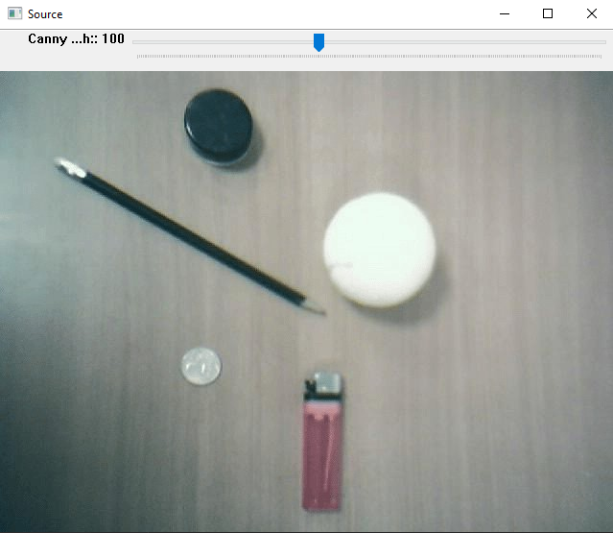

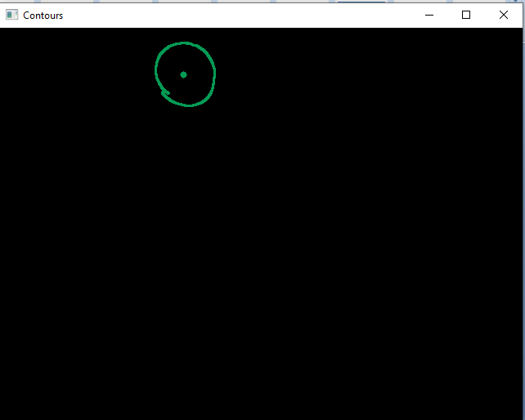

РОБОТА УСПІШНА!

**31) Point Polygon Test**

БУЛО:

from __future__ import print_function

from __future__ import division

import cv2 as cv

import numpy as np

# Create an image

r = 100

src = np.zeros((4*r, 4*r), dtype=np.uint8)

# Create a sequence of points to make a contour

vert = [None]*6

vert[0] = (3*r//2, int(1.34*r))

vert[1] = (1*r, 2*r)

vert[2] = (3*r//2, int(2.866*r))

vert[3] = (5*r//2, int(2.866*r))

vert[4] = (3*r, 2*r)

vert[5] = (5*r//2, int(1.34*r))

# Draw it in src

for i in range(6):

[cv.line](https://docs.opencv.org/4.x/d6/d6e/group__imgproc__draw.html#ga7078a9fae8c7e7d13d24dac2520ae4a2)(src, vert[i], vert[(i+1)%6], ( 255 ), 3)

# Get the contours

contours, _ = [cv.findContours](https://docs.opencv.org/4.x/d3/dc0/group__imgproc__shape.html#gae4156f04053c44f886e387cff0ef6e08)(src, cv.RETR_TREE, cv.CHAIN_APPROX_SIMPLE)

# Calculate the distances to the contour

raw_dist = np.empty(src.shape, dtype=np.float32)

for i in range(src.shape[0]):

for j in range(src.shape[1]):

raw_dist[i,j] = [cv.pointPolygonTest](https://docs.opencv.org/4.x/d3/dc0/group__imgproc__shape.html#ga1a539e8db2135af2566103705d7a5722)(contours[0], (j,i), True)

minVal, maxVal, _, maxDistPt = [cv.minMaxLoc](https://docs.opencv.org/4.x/d2/de8/group__core__array.html#ga8873b86a29c5af51cafdcee82f8150a7)(raw_dist)

minVal = [abs](https://docs.opencv.org/4.x/d1/d10/classcv_1_1MatExpr.html#a30843fc6c148a00f5d300a7f43f3fbdc)(minVal)

maxVal = [abs](https://docs.opencv.org/4.x/d1/d10/classcv_1_1MatExpr.html#a30843fc6c148a00f5d300a7f43f3fbdc)(maxVal)

# Depicting the distances graphically

drawing = np.zeros((src.shape[0], src.shape[1], 3), dtype=np.uint8)

for i in range(src.shape[0]):

for j in range(src.shape[1]):

if raw_dist[i,j] < 0:

drawing[i,j,0] = 255 - [abs](https://docs.opencv.org/4.x/d1/d10/classcv_1_1MatExpr.html#a30843fc6c148a00f5d300a7f43f3fbdc)(raw_dist[i,j]) * 255 / minVal

elif raw_dist[i,j] > 0:

drawing[i,j,2] = 255 - raw_dist[i,j] * 255 / maxVal

else:

drawing[i,j,0] = 255

drawing[i,j,1] = 255

drawing[i,j,2] = 255

[cv.circle](https://docs.opencv.org/4.x/d6/d6e/group__imgproc__draw.html#gaf10604b069374903dbd0f0488cb43670)(drawing,maxDistPt, int(maxVal),(255,255,255), 1, cv.LINE_8, 0)

[cv.imshow](https://docs.opencv.org/4.x/df/d24/group__highgui__opengl.html#gaae7e90aa3415c68dba22a5ff2cefc25d)('Source', src)

[cv.imshow](https://docs.opencv.org/4.x/df/d24/group__highgui__opengl.html#gaae7e90aa3415c68dba22a5ff2cefc25d)('Distance and inscribed circle', drawing)

[cv.waitKey](https://docs.opencv.org/4.x/d7/dfc/group__highgui.html#ga5628525ad33f52eab17feebcfba38bd7)()

РОБОТА НЕУСПІШНА!

СТАЛО:

from __future__ import print_function  
from __future__ import division  
import cv2 as cv  
import numpy as np  
# Create an image  
r = 100  
src = np.zeros((4*r, 4*r), dtype=np.uint8)  
# Create a sequence of points to make a contour  
vert = [None]*6  
vert[0] = (3*r//2, int(1.34*r))  
vert[1] = (1*r, 2*r)  
vert[2] = (3*r//2, int(2.866*r))  
vert[3] = (5*r//2, int(2.866*r))  
vert[4] = (3*r, 2*r)  
vert[5] = (5*r//2, int(1.34*r))  
# Draw it in src  
for i in range(6):  
 cv.line(src, vert[i], vert[(i+1)%6], ( 255 ), 3)  
# Get the contours  
contours, _ = cv.findContours(src, cv.RETR_TREE, cv.CHAIN_APPROX_SIMPLE)  
# Calculate the distances to the contour  
raw_dist = np.empty(src.shape, dtype=np.float32)  
for i in range(src.shape[0]):  
 for j in range(src.shape[1]): raw_dist[i,j] = cv.pointPolygonTest(contours[0], (j,i), True)  
minVal, maxVal, _, maxDistPt = cv.minMaxLoc(raw_dist)  
minVal = abs(minVal)  
maxVal = abs(maxVal)  
# Depicting the distances graphically  
drawing = np.zeros((src.shape[0], src.shape[1], 3), dtype=np.uint8)  
for i in range(src.shape[0]):  
 for j in range(src.shape[1]):  
 if raw_dist[i,j] < 0: drawing[i,j,0] = 255 - abs(raw_dist[i,j]) * 255 / minVal  
 elif raw_dist[i,j] > 0: drawing[i,j,2] = 255 - raw_dist[i,j] * 255 / maxVal  
else: drawing[i,j,0] = 255  
drawing[i,j,1] = 255  
drawing[i,j,2] = 255  
cv.circle(drawing,maxDistPt, int(maxVal),(255,255,255), 1, cv.LINE_8, 0)  
cv.imshow('Source', src)  
cv.imshow('Distance and inscribed circle', drawing)  
cv.waitKey()

Єдина проблема була у відступах. Через це виникало помилку!

Це завдання утворює шестикутник, з одного боку – чорно-білим, а з іншого – червоний, у якого вписане коло.

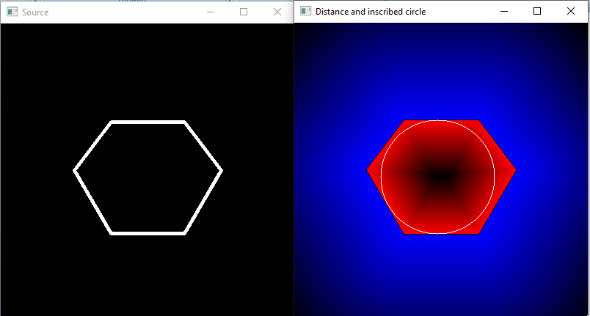

РОБОТА УСПІШНА!

**32) Image Segmentation with Distance Transform and Watershed Algorithm**

БУЛО:

from __future__ import print_function  
import cv2 as cv  
import numpy as np  
import argparse  
import random as rng  
rng.seed(12345)  
parser = argparse.ArgumentParser(description='Code for Image Segmentation with Distance Transform and Watershed Algorithm.\  
 Sample code showing how to segment overlapping objects using Laplacian filtering, \  
 in addition to Watershed and Distance Transformation')  
parser.add_argument('--input', help='Path to input image.', default='G:/Python/cards.png')  
args = parser.parse_args()  
src = cv.imread(cv.samples.findFile(args.input))  
if src is None:  
 print('Could not open or find the image:', args.input)  
 exit(0)  
# Show source image  
cv.imshow('Source Image', src)  
src[np.all(src == 255, axis=2)] = 0  
# Show output image  
cv.imshow('Black Background Image', src)  
kernel = np.array([[1, 1, 1], [1, -8, 1], [1, 1, 1]], dtype=np.float32)  
# do the laplacian filtering as it is  
# well, we need to convert everything in something more deeper then CV_8U  
# because the kernel has some negative values,  
# and we can expect in general to have a Laplacian image with negative values  
# BUT a 8bits unsigned int (the one we are working with) can contain values from 0 to 255  
# so the possible negative number will be truncated  
imgLaplacian = cv.filter2D(src, cv.CV_32F, kernel)  
sharp = np.float32(src)  
imgResult = sharp - imgLaplacian  
# convert back to 8bits gray scale  
imgResult = np.clip(imgResult, 0, 255)  
imgResult = imgResult.astype('uint8')  
imgLaplacian = np.clip(imgLaplacian, 0, 255)  
imgLaplacian = np.uint8(imgLaplacian)  
#cv.imshow('Laplace Filtered Image', imgLaplacian)  
cv.imshow('New Sharped Image', imgResult)  
bw = cv.cvtColor(imgResult, cv.COLOR_BGR2GRAY)  
_, bw = cv.threshold(bw, 40, 255, cv.THRESH_BINARY | cv.THRESH_OTSU)  
cv.imshow('Binary Image', bw)  
dist = cv.distanceTransform(bw, cv.DIST_L2, 3)  
# Normalize the distance image for range = {0.0, 1.0}  
# so we can visualize and threshold it  
cv.normalize(dist, dist, 0, 1.0, cv.NORM_MINMAX)  
cv.imshow('Distance Transform Image', dist)  
_, dist = cv.threshold(dist, 0.4, 1.0, cv.THRESH_BINARY)  
# Dilate a bit the dist image  
kernel1 = np.ones((3,3), dtype=np.uint8)  
dist = cv.dilate(dist, kernel1)  
cv.imshow('Peaks', dist)  
dist_8u = dist.astype('uint8')  
# Find total markers  
contours, _ = cv.findContours(dist_8u, cv.RETR_EXTERNAL, cv.CHAIN_APPROX_SIMPLE)  
# Create the marker image for the watershed algorithm  
markers = np.zeros(dist.shape, dtype=np.int32)  
# Draw the foreground markers  
for i in range(len(contours)):  
 cv.drawContours(markers, contours, i, (i+1), -1)  
# Draw the background marker  
cv.circle(markers, (5,5), 3, (255,255,255), -1)  
markers_8u = (markers * 10).astype('uint8')  
cv.imshow('Markers', markers_8u)  
cv.watershed(imgResult, markers)  
#mark = np.zeros(markers.shape, dtype=np.uint8)  
mark = markers.astype('uint8')  
mark = cv.bitwise_not(mark)  
# uncomment this if you want to see how the mark  
# image looks like at that point  
#cv.imshow('Markers_v2', mark)  
# Generate random colors  
colors = []  
for contour in contours:  
 colors.append((rng.randint(0,256), rng.randint(0,256), rng.randint(0,256)))  
# Create the result image  
dst = np.zeros((markers.shape[0], markers.shape[1], 3), dtype=np.uint8)  
# Fill labeled objects with random colors  
for i in range(markers.shape[0]):  
 for j in range(markers.shape[1]):  
 index = markers[i,j]  
 if index > 0 and index <= len(contours):  
 dst[i,j,:] = colors[index-1]  
# Visualize the final image  
cv.imshow('Final Result', dst)  
cv.waitKey()

РОБОТА НЕУСПІШНА!

СТАЛО:

from __future__ import print_function  
import cv2 as cv  
import numpy as np  
import argparse  
import random as rng  
rng.seed(12345)  
parser = argparse.ArgumentParser(description='Code for Image Segmentation with Distance Transform and Watershed Algorithm.\  
 Sample code showing how to segment overlapping objects using Laplacian filtering, \  
 in addition to Watershed and Distance Transformation')  
parser.add_argument('--input', help='Path to input image.', default='G:/Python/cards.png')  
args = parser.parse_args()  
src = cv.imread(cv.samples.findFile(args.input))  
if src is None:  
 print('Could not open or find the image:', args.input)  
 exit(0)  
# Show source image  
cv.imshow('Source Image', src)  
src[np.all(src == 255, axis=2)] = 0  
# Show output image  
cv.imshow('Black Background Image', src)  
kernel = np.array([[1, 1, 1], [1, -8, 1], [1, 1, 1]], dtype=np.float32)  
# do the laplacian filtering as it is  
# well, we need to convert everything in something more deeper then CV_8U  
# because the kernel has some negative values,  
# and we can expect in general to have a Laplacian image with negative values  
# BUT a 8bits unsigned int (the one we are working with) can contain values from 0 to 255  
# so the possible negative number will be truncated  
imgLaplacian = cv.filter2D(src, cv.CV_32F, kernel)  
sharp = np.float32(src)  
imgResult = sharp - imgLaplacian  
# convert back to 8bits gray scale  
imgResult = np.clip(imgResult, 0, 255)  
imgResult = imgResult.astype('uint8')  
imgLaplacian = np.clip(imgLaplacian, 0, 255)  
imgLaplacian = np.uint8(imgLaplacian)  
#cv.imshow('Laplace Filtered Image', imgLaplacian)  
cv.imshow('New Sharped Image', imgResult)  
bw = cv.cvtColor(imgResult, cv.COLOR_BGR2GRAY)  
_, bw = cv.threshold(bw, 40, 255, cv.THRESH_BINARY | cv.THRESH_OTSU)  
cv.imshow('Binary Image', bw)  
dist = cv.distanceTransform(bw, cv.DIST_L2, 3)  
# Normalize the distance image for range = {0.0, 1.0}  
# so we can visualize and threshold it  
cv.normalize(dist, dist, 0, 1.0, cv.NORM_MINMAX)  
cv.imshow('Distance Transform Image', dist)  
_, dist = cv.threshold(dist, 0.4, 1.0, cv.THRESH_BINARY)  
# Dilate a bit the dist image  
kernel1 = np.ones((3,3), dtype=np.uint8)  
dist = cv.dilate(dist, kernel1)  
cv.imshow('Peaks', dist)  
dist_8u = dist.astype('uint8')  
# Find total markers  
contours, _ = cv.findContours(dist_8u, cv.RETR_EXTERNAL, cv.CHAIN_APPROX_SIMPLE)  
# Create the marker image for the watershed algorithm  
markers = np.zeros(dist.shape, dtype=np.int32)  
# Draw the foreground markers  
for i in range(len(contours)):  
 cv.drawContours(markers, contours, i, (i+1), -1)  
# Draw the background marker  
cv.circle(markers, (5,5), 3, (255,255,255), -1)  
markers_8u = (markers * 10).astype('uint8')  
cv.imshow('Markers', markers_8u)  
cv.watershed(imgResult, markers)  
#mark = np.zeros(markers.shape, dtype=np.uint8)  
mark = markers.astype('uint8')  
mark = cv.bitwise_not(mark)  
# uncomment this if you want to see how the mark  
# image looks like at that point  
#cv.imshow('Markers_v2', mark)  
# Generate random colors  
colors = []  
for contour in contours:  
 colors.append((rng.randint(0,256), rng.randint(0,256), rng.randint(0,256)))  
# Create the result image  
dst = np.zeros((markers.shape[0], markers.shape[1], 3), dtype=np.uint8)  
# Fill labeled objects with random colors  
for i in range(markers.shape[0]):  
 for j in range(markers.shape[1]):  
 index = markers[i,j]  
 if index > 0 and index <= len(contours):  
 dst[i,j,:] = colors[index-1]  
# Visualize the final image  
cv.imshow('Final Result', dst)  
cv.waitKey()

Єдина проблема була у відступах. Через це виникало помилку!

Це завдання різноманітне. Воно робить фон чорним, а фронт-енд цікавим. Тобто, кольоровим, чорно-білим та тому подібне.

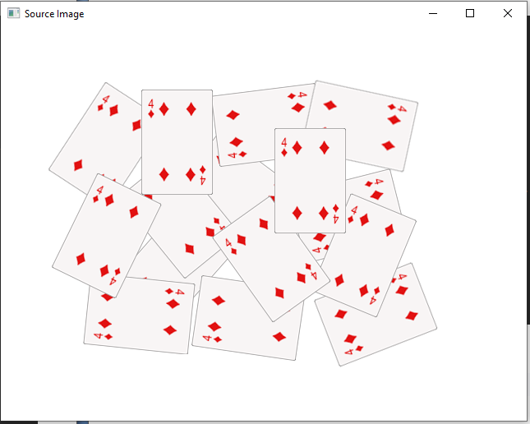

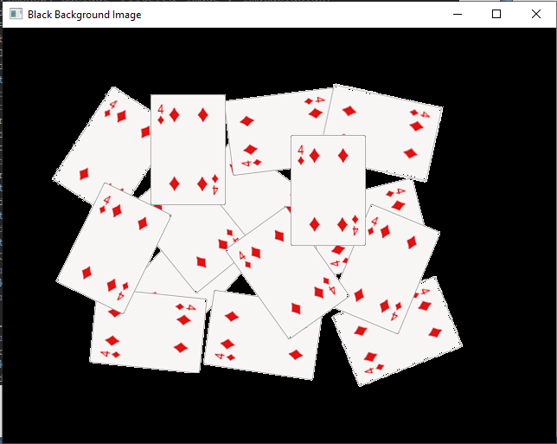

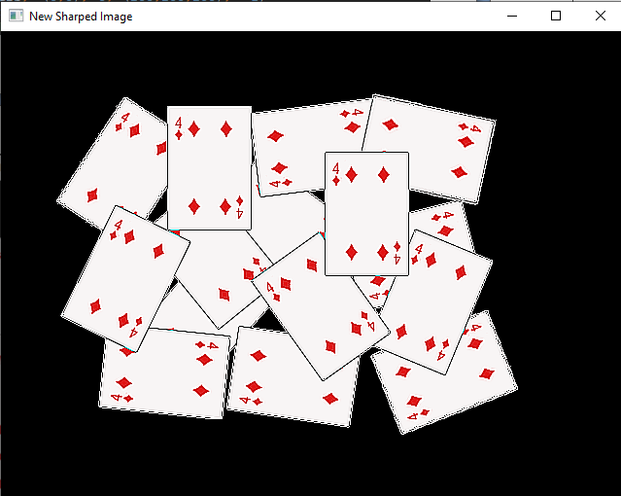

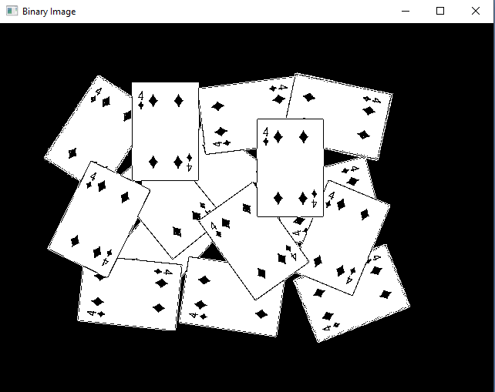

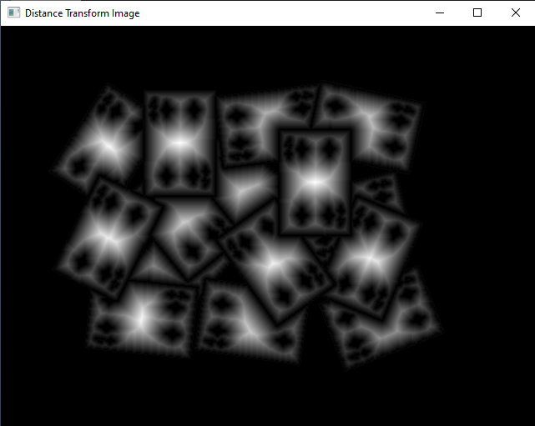

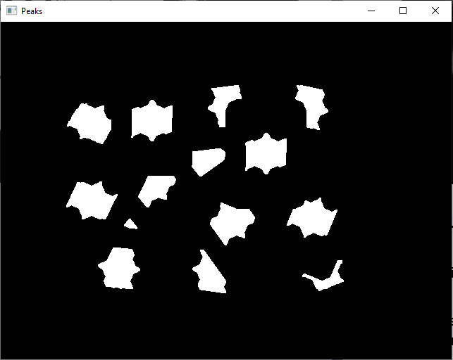

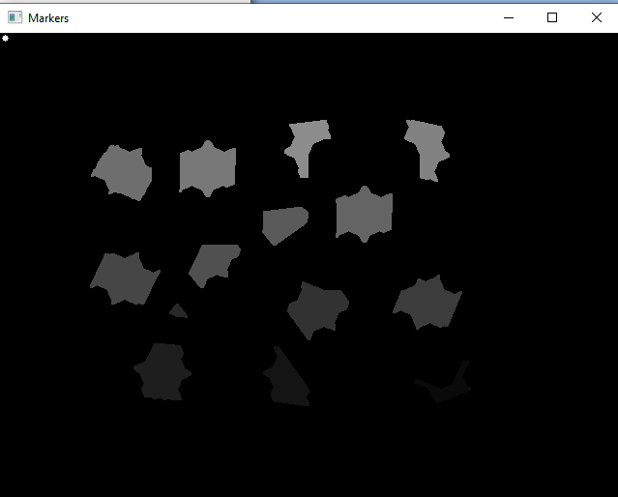

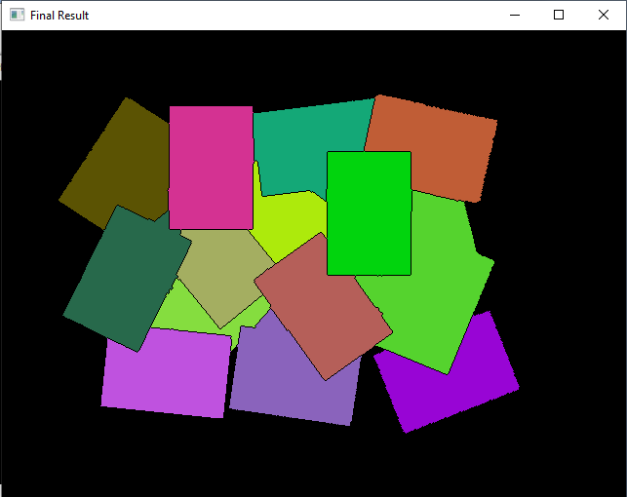

РОБОТА УСПІШНА!

**33) Out-of-focus Deblur Filter**

#include <iostream>  
#include "opencv2/highgui.hpp"  
#include "opencv2/imgproc.hpp"  
#include "opencv2/imgcodecs.hpp"  
using namespace cv;  
using namespace std;  
void help();  
void calcPSF(Mat& outputImg, Size filterSize, int R);  
void fftshift(const Mat& inputImg, Mat& outputImg);  
void filter2DFreq(const Mat& inputImg, Mat& outputImg, const Mat& H);  
void calcWnrFilter(const Mat& input_h_PSF, Mat& output_G, double nsr);  
const String keys =  
"{help h usage ? | | print this message }"  
"{image |original.jpg | input image name }"  
"{R |5 | radius }"  
"{SNR |100 | signal to noise ratio}"  
;  
int main(int argc, char *argv[])  
{  
 help();  
 CommandLineParser parser(argc, argv, keys);  
 if (parser.has("help"))  
 {  
 parser.printMessage();  
 return 0;  
 }  
 int R = parser.get<int>("R");  
 int snr = parser.get<int>("SNR");  
 string strInFileName = parser.get<String>("image");  
 samples::addSamplesDataSearchSubDirectory("doc/tutorials/imgproc/out_of_focus_deblur_filter/images");  
 if (!parser.check())  
 {  
 parser.printErrors();  
 return 0;  
 }  
 Mat imgIn;  
 imgIn = imread(samples::findFile( strInFileName ), IMREAD_GRAYSCALE);  
 if (imgIn.empty()) //check whether the image is loaded or not  
 {  
 cout << "ERROR : Image cannot be loaded..!!" << endl;  
 return -1;  
 }  
 Mat imgOut;  
 // it needs to process even image only  
 Rect roi = Rect(0, 0, imgIn.cols & -2, imgIn.rows & -2);  
 //Hw calculation (start)  
 Mat Hw, h;  
 calcPSF(h, roi.size(), R);  
 calcWnrFilter(h, Hw, 1.0 / double(snr));  
 //Hw calculation (stop)  
 // filtering (start)  
 filter2DFreq(imgIn(roi), imgOut, Hw);  
 // filtering (stop)  
 imgOut.convertTo(imgOut, CV_8U);  
 normalize(imgOut, imgOut, 0, 255, NORM_MINMAX);  
 imshow("Original", imgIn);  
 imshow("Debluring", imgOut);  
 imwrite("result.jpg", imgOut);  
 waitKey(0);  
 return 0;  
}  
void help()  
{  
 cout << "2018-07-12" << endl;  
 cout << "DeBlur_v8" << endl;  
 cout << "You will learn how to recover an out-of-focus image by Wiener filter" << endl;  
}  
void calcPSF(Mat& outputImg, Size filterSize, int R)  
{  
 Mat h(filterSize, CV_32F, Scalar(0));  
 Point point(filterSize.width / 2, filterSize.height / 2);  
 circle(h, point, R, 255, -1, 8);  
 Scalar summa = sum(h);  
 outputImg = h / summa[0];  
}  
void fftshift(const Mat& inputImg, Mat& outputImg)  
{  
 outputImg = inputImg.clone();  
 int cx = outputImg.cols / 2;  
 int cy = outputImg.rows / 2;  
 Mat q0(outputImg, Rect(0, 0, cx, cy));  
 Mat q1(outputImg, Rect(cx, 0, cx, cy));  
 Mat q2(outputImg, Rect(0, cy, cx, cy));  
 Mat q3(outputImg, Rect(cx, cy, cx, cy));  
 Mat tmp;  
 q0.copyTo(tmp);  
 q3.copyTo(q0);  
 tmp.copyTo(q3);  
 q1.copyTo(tmp);  
 q2.copyTo(q1);  
 tmp.copyTo(q2);  
}  
void filter2DFreq(const Mat& inputImg, Mat& outputImg, const Mat& H)  
{  
 Mat planes[2] = { Mat_<float>(inputImg.clone()), Mat::zeros(inputImg.size(), CV_32F) };  
 Mat complexI;  
 merge(planes, 2, complexI);  
 dft(complexI, complexI, DFT_SCALE);  
 Mat planesH[2] = { Mat_<float>(H.clone()), Mat::zeros(H.size(), CV_32F) };  
 Mat complexH;  
 merge(planesH, 2, complexH);  
 Mat complexIH;  
 mulSpectrums(complexI, complexH, complexIH, 0);  
 idft(complexIH, complexIH);  
 split(complexIH, planes);  
 outputImg = planes[0];  
}  
void calcWnrFilter(const Mat& input_h_PSF, Mat& output_G, double nsr)  
{  
 Mat h_PSF_shifted;  
 fftshift(input_h_PSF, h_PSF_shifted);  
 Mat planes[2] = { Mat_<float>(h_PSF_shifted.clone()), Mat::zeros(h_PSF_shifted.size(), CV_32F) };  
 Mat complexI;  
 merge(planes, 2, complexI);  
 dft(complexI, complexI);  
 split(complexI, planes);  
 Mat denom;  
 pow(abs(planes[0]), 2, denom);  
 denom += nsr;  
 divide(planes[0], denom, output_G);  
}

Нижче ви можете побачити справжнє розфокусоване зображення:

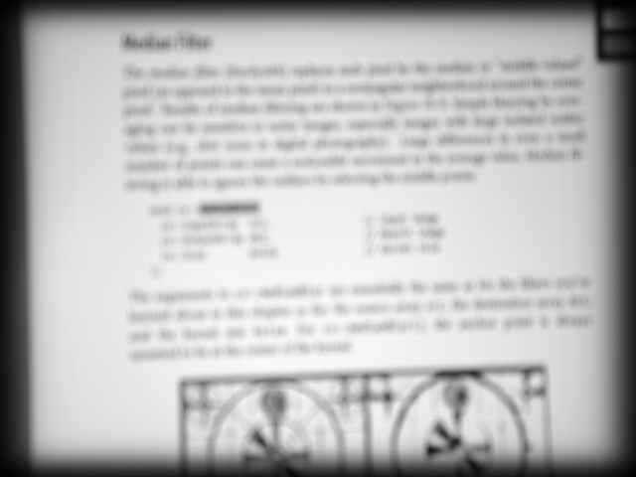

**Нефокусне зображення**

І був обчислений наступний результат Р= 53 і СНР= 5200 параметрів:

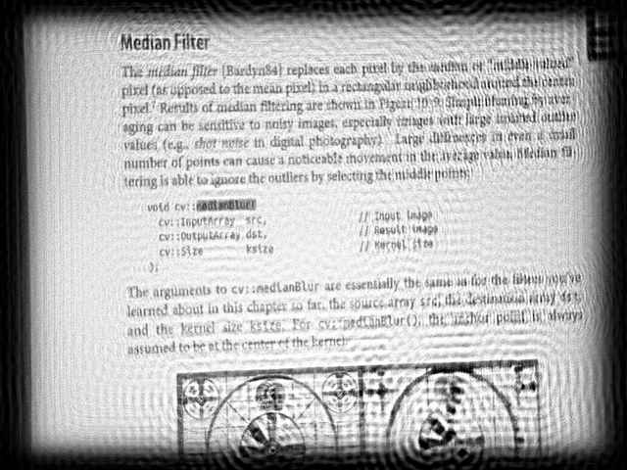

**Відновлене (розмите) зображення**

**34) Motion Deblur Filter**

#include <iostream>  
#include "opencv2/imgproc.hpp"  
#include "opencv2/imgcodecs.hpp"  
using namespace cv;  
using namespace std;  
void help();  
void calcPSF(Mat& outputImg, Size filterSize, int len, double theta);  
void fftshift(const Mat& inputImg, Mat& outputImg);  
void filter2DFreq(const Mat& inputImg, Mat& outputImg, const Mat& H);  
void calcWnrFilter(const Mat& input_h_PSF, Mat& output_G, double nsr);  
void edgetaper(const Mat& inputImg, Mat& outputImg, double gamma = 5.0, double beta = 0.2);  
const String keys =  
"{help h usage ? | | print this message }"  
"{image |input.png | input image name }"  
"{LEN |125 | length of a motion }"  
"{THETA |0 | angle of a motion in degrees }"  
"{SNR |700 | signal to noise ratio }"  
;  
int main(int argc, char *argv[])  
{  
 help();  
 CommandLineParser parser(argc, argv, keys);  
 if (parser.has("help"))  
 {  
 parser.printMessage();  
 return 0;  
 }  
 int LEN = parser.get<int>("LEN");  
 double THETA = parser.get<double>("THETA");  
 int snr = parser.get<int>("SNR");  
 string strInFileName = parser.get<String>("image");  
 if (!parser.check())  
 {  
 parser.printErrors();  
 return 0;  
 }  
 Mat imgIn;  
 imgIn = imread(strInFileName, IMREAD_GRAYSCALE);  
 if (imgIn.empty()) //check whether the image is loaded or not  
 {  
 cout << "ERROR : Image cannot be loaded..!!" << endl;  
 return -1;  
 }  
 Mat imgOut;  
 // it needs to process even image only  
 Rect roi = Rect(0, 0, imgIn.cols & -2, imgIn.rows & -2);  
 //Hw calculation (start)  
 Mat Hw, h;  
 calcPSF(h, roi.size(), LEN, THETA);  
 calcWnrFilter(h, Hw, 1.0 / double(snr));  
 //Hw calculation (stop)  
 imgIn.convertTo(imgIn, CV_32F);  
 edgetaper(imgIn, imgIn);  
 // filtering (start)  
 filter2DFreq(imgIn(roi), imgOut, Hw);  
 // filtering (stop)  
 imgOut.convertTo(imgOut, CV_8U);  
 normalize(imgOut, imgOut, 0, 255, NORM_MINMAX);  
 imwrite("result.jpg", imgOut);  
 return 0;  
}  
void help()  
{  
 cout << "2018-08-14" << endl;  
 cout << "Motion_deblur_v2" << endl;  
 cout << "You will learn how to recover an image with motion blur distortion using a Wiener filter" << endl;  
}  
void calcPSF(Mat& outputImg, Size filterSize, int len, double theta)  
{  
 Mat h(filterSize, CV_32F, Scalar(0));  
 Point point(filterSize.width / 2, filterSize.height / 2);  
 ellipse(h, point, Size(0, cvRound(float(len) / 2.0)), 90.0 - theta, 0, 360, Scalar(255), FILLED);  
 Scalar summa = sum(h);  
 outputImg = h / summa[0];  
}  
void fftshift(const Mat& inputImg, Mat& outputImg)  
{  
 outputImg = inputImg.clone();  
 int cx = outputImg.cols / 2;  
 int cy = outputImg.rows / 2;  
 Mat q0(outputImg, Rect(0, 0, cx, cy));  
 Mat q1(outputImg, Rect(cx, 0, cx, cy));  
 Mat q2(outputImg, Rect(0, cy, cx, cy));  
 Mat q3(outputImg, Rect(cx, cy, cx, cy));  
 Mat tmp;  
 q0.copyTo(tmp);  
 q3.copyTo(q0);  
 tmp.copyTo(q3);  
 q1.copyTo(tmp);  
 q2.copyTo(q1);  
 tmp.copyTo(q2);  
}  
void filter2DFreq(const Mat& inputImg, Mat& outputImg, const Mat& H)  
{  
 Mat planes[2] = { Mat_<float>(inputImg.clone()), Mat::zeros(inputImg.size(), CV_32F) };  
 Mat complexI;  
 merge(planes, 2, complexI);  
 dft(complexI, complexI, DFT_SCALE);  
 Mat planesH[2] = { Mat_<float>(H.clone()), Mat::zeros(H.size(), CV_32F) };  
 Mat complexH;  
 merge(planesH, 2, complexH);  
 Mat complexIH;  
 mulSpectrums(complexI, complexH, complexIH, 0);  
 idft(complexIH, complexIH);  
 split(complexIH, planes);  
 outputImg = planes[0];  
}  
void calcWnrFilter(const Mat& input_h_PSF, Mat& output_G, double nsr)  
{  
 Mat h_PSF_shifted;  
 fftshift(input_h_PSF, h_PSF_shifted);  
 Mat planes[2] = { Mat_<float>(h_PSF_shifted.clone()), Mat::zeros(h_PSF_shifted.size(), CV_32F) };  
 Mat complexI;  
 merge(planes, 2, complexI);  
 dft(complexI, complexI);  
 split(complexI, planes);  
 Mat denom;  
 pow(abs(planes[0]), 2, denom);  
 denom += nsr;  
 divide(planes[0], denom, output_G);  
}  
void edgetaper(const Mat& inputImg, Mat& outputImg, double gamma, double beta)  
{  
 int Nx = inputImg.cols;  
 int Ny = inputImg.rows;  
 Mat w1(1, Nx, CV_32F, Scalar(0));  
 Mat w2(Ny, 1, CV_32F, Scalar(0));  
 float* p1 = w1.ptr<float>(0);  
 float* p2 = w2.ptr<float>(0);  
 float dx = float(2.0 * CV_PI / Nx);  
 float x = float(-CV_PI);  
 for (int i = 0; i < Nx; i++)  
 {  
 p1[i] = float(0.5 * (tanh((x + gamma / 2) / beta) - tanh((x - gamma / 2) / beta)));  
 x += dx;  
 }  
 float dy = float(2.0 * CV_PI / Ny);  
 float y = float(-CV_PI);  
 for (int i = 0; i < Ny; i++)  
 {  
 p2[i] = float(0.5 * (tanh((y + gamma / 2) / beta) - tanh((y - gamma / 2) / beta)));  
 y += dy;  
 }  
 Mat w = w2 * w1;  
 multiply(inputImg, w, outputImg);  
}

Нижче ви можете побачити зображення реального світу з спотворенням розмиття. Номерний знак на обох автомобілях не читається. Червоні маркери показують місце розташування номерного знака автомобіля.

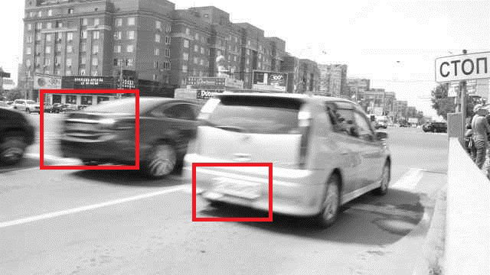

**Розмиття зображення. Номерні знаки не читаються**

Нижче ви можете побачити результат відновлення чорного номерного знака автомобіля. Результат обчислено за допомогоюЛ ЕН= 125,ТХEТА= 0,СНР= 700.

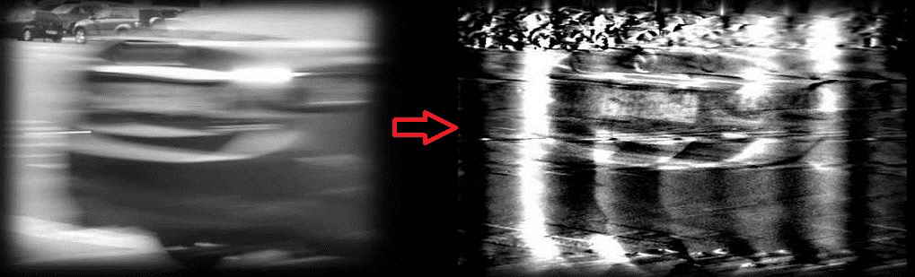

**Відновлене зображення чорного номерного знака автомобіля**

Нижче ви можете побачити результат відновлення білого номерного знака автомобіля. Результат обчислено за допомогоюЛ ЕН= 78,ТХEТА= 15,СНР= 300.

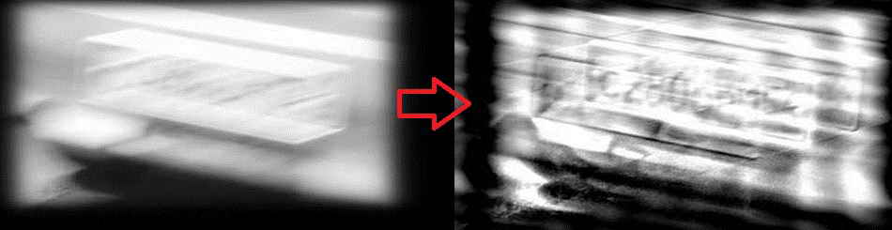

**Відновлене зображення білого номерного знака автомобіля**

**35) Anisotropic image segmentation by a gradient structure tensor**

БУЛО:

import cv2 as cv  
import numpy as np  
import argparse  
  
W = 52 # window size is WxW  
C_Thr = 0.43 # threshold for coherency  
LowThr = 35 # threshold1 for orientation, it ranges from 0 to 180  
HighThr = 57 # threshold2 for orientation, it ranges from 0 to 180  
  
  
def calcGST(inputIMG, w):  
 img = inputIMG.astype(np.float32)  
 # GST components calculation (start)  
 # J = (J11 J12; J12 J22) - GST  
 imgDiffX = cv.Sobel(img, cv.CV_32F, 1, 0, 3)  
 imgDiffY = cv.Sobel(img, cv.CV_32F, 0, 1, 3)  
 imgDiffXY = cv.multiply(imgDiffX, imgDiffY)  
  
 imgDiffXX = cv.multiply(imgDiffX, imgDiffX)  
 imgDiffYY = cv.multiply(imgDiffY, imgDiffY)  
 J11 = cv.boxFilter(imgDiffXX, cv.CV_32F, (w, w))  
 J22 = cv.boxFilter(imgDiffYY, cv.CV_32F, (w, w))  
 J12 = cv.boxFilter(imgDiffXY, cv.CV_32F, (w, w))  
 # GST components calculations (stop)  
 # eigenvalue calculation (start)  
 # lambda1 = 0.5*(J11 + J22 + sqrt((J11-J22)^2 + 4*J12^2))  
 # lambda2 = 0.5*(J11 + J22 - sqrt((J11-J22)^2 + 4*J12^2))  
 tmp1 = J11 + J22  
 tmp2 = J11 - J22  
 tmp2 = cv.multiply(tmp2, tmp2)  
 tmp3 = cv.multiply(J12, J12)  
 tmp4 = np.sqrt(tmp2 + 4.0 * tmp3)  
 lambda1 = 0.5 * (tmp1 + tmp4) # biggest eigenvalue  
 lambda2 = 0.5 * (tmp1 - tmp4) # smallest eigenvalue  
 # eigenvalue calculation (stop)  
 # Coherency calculation (start)  
 # Coherency = (lambda1 - lambda2)/(lambda1 + lambda2)) - measure of anisotropism  
 # Coherency is anisotropy degree (consistency of local orientation)  
 imgCoherencyOut = cv.divide(lambda1 - lambda2, lambda1 + lambda2)  
 # Coherency calculation (stop)  
 # orientation angle calculation (start)  
 # tan(2*Alpha) = 2*J12/(J22 - J11)  
 # Alpha = 0.5 atan2(2*J12/(J22 - J11))  
 imgOrientationOut = cv.phase(J22 - J11, 2.0 * J12, angleInDegrees=True)  
 imgOrientationOut = 0.5 * imgOrientationOut  
 # orientation angle calculation (stop)  
 return imgCoherencyOut, imgOrientationOut  
  
  
parser = argparse.ArgumentParser(description='Code for Anisotropic image segmentation tutorial.')  
parser.add_argument('-i', '--input', help='Path to input image.', required=True)  
args = parser.parse_args()  
imgIn = cv.imread(args.input, cv.IMREAD_GRAYSCALE)  
if imgIn is None:  
 print('Could not open or find the image: {}'.format(args.input))  
 exit(0)  
imgCoherency, imgOrientation = calcGST(imgIn, W)  
_, imgCoherencyBin = cv.threshold(imgCoherency, C_Thr, 255, cv.THRESH_BINARY)  
_, imgOrientationBin = cv.threshold(imgOrientation, LowThr, HighThr, cv.THRESH_BINARY)  
imgBin = cv.bitwise_and(imgCoherencyBin, imgOrientationBin)  
imgCoherency = cv.normalize(imgCoherency, None, alpha=0, beta=1, norm_type=cv.NORM_MINMAX, dtype=cv.CV_32F)  
imgOrientation = cv.normalize(imgOrientation, None, alpha=0, beta=1, norm_type=cv.NORM_MINMAX, dtype=cv.CV_32F)  
cv.imshow('result.jpg', np.uint8(0.5 * (imgIn + imgBin)))  
cv.imshow('Coherency.jpg', imgCoherency)  
cv.imshow('Orientation.jpg', imgOrientation)  
cv.waitKey(0)

РОБОТА НЕУСПІШНА!

СТАЛО:

import cv2 as cv  
import numpy as np  
#import argparse  
  
W = 52 # window size is WxW  
C_Thr = 0.43 # threshold for coherency  
LowThr = 35 # threshold1 for orientation, it ranges from 0 to 180  
HighThr = 57 # threshold2 for orientation, it ranges from 0 to 180  
  
  
def calcGST(inputIMG, w):  
 img = inputIMG.astype(np.float32)  
 # GST components calculation (start)  
 # J = (J11 J12; J12 J22) - GST  
 imgDiffX = cv.Sobel(img, cv.CV_32F, 1, 0, 3)  
 imgDiffY = cv.Sobel(img, cv.CV_32F, 0, 1, 3)  
 imgDiffXY = cv.multiply(imgDiffX, imgDiffY)  
  
 imgDiffXX = cv.multiply(imgDiffX, imgDiffX)  
 imgDiffYY = cv.multiply(imgDiffY, imgDiffY)  
 J11 = cv.boxFilter(imgDiffXX, cv.CV_32F, (w, w))  
 J22 = cv.boxFilter(imgDiffYY, cv.CV_32F, (w, w))  
 J12 = cv.boxFilter(imgDiffXY, cv.CV_32F, (w, w))  
 # GST components calculations (stop)  
 # eigenvalue calculation (start)  
 # lambda1 = 0.5*(J11 + J22 + sqrt((J11-J22)^2 + 4*J12^2))  
 # lambda2 = 0.5*(J11 + J22 - sqrt((J11-J22)^2 + 4*J12^2))  
 tmp1 = J11 + J22  
 tmp2 = J11 - J22  
 tmp2 = cv.multiply(tmp2, tmp2)  
 tmp3 = cv.multiply(J12, J12)  
 tmp4 = np.sqrt(tmp2 + 4.0 * tmp3)  
 lambda1 = 0.5 * (tmp1 + tmp4) # biggest eigenvalue  
 lambda2 = 0.5 * (tmp1 - tmp4) # smallest eigenvalue  
 # eigenvalue calculation (stop)  
 # Coherency calculation (start)  
 # Coherency = (lambda1 - lambda2)/(lambda1 + lambda2)) - measure of anisotropism  
 # Coherency is anisotropy degree (consistency of local orientation)  
 imgCoherencyOut = cv.divide(lambda1 - lambda2, lambda1 + lambda2)  
 # Coherency calculation (stop)  
 # orientation angle calculation (start)  
 # tan(2*Alpha) = 2*J12/(J22 - J11)  
 # Alpha = 0.5 atan2(2*J12/(J22 - J11))  
 imgOrientationOut = cv.phase(J22 - J11, 2.0 * J12, angleInDegrees=True)  
 imgOrientationOut = 0.5 * imgOrientationOut  
 # orientation angle calculation (stop)  
 return imgCoherencyOut, imgOrientationOut  
  
  
#parser = argparse.ArgumentParser(description='Code for Anisotropic image segmentation tutorial.')  
#parser.add_argument('-i', '--input', help='Path to input image.', required=True)  
#args = parser.parse_args()  
imgIn = cv.imread("G:/Python/home.jpg", cv.IMREAD_GRAYSCALE)  
if imgIn is None:  
 print('Could not open or find the image: G:/Python/home.jpg')  
 exit(0)  
imgCoherency, imgOrientation = calcGST(imgIn, W)  
_, imgCoherencyBin = cv.threshold(imgCoherency, C_Thr, 255, cv.THRESH_BINARY)  
_, imgOrientationBin = cv.threshold(imgOrientation, LowThr, HighThr, cv.THRESH_BINARY)  
imgBin = cv.bitwise_and(imgCoherencyBin, imgOrientationBin)  
imgCoherency = cv.normalize(imgCoherency, None, alpha=0, beta=1, norm_type=cv.NORM_MINMAX, dtype=cv.CV_32F)  
imgOrientation = cv.normalize(imgOrientation, None, alpha=0, beta=1, norm_type=cv.NORM_MINMAX, dtype=cv.CV_32F)  
cv.imshow('result.jpg', np.uint8(0.5 * (imgIn + imgBin)))  
cv.imshow('Coherency.jpg', imgCoherency)  
cv.imshow('Orientation.jpg', imgOrientation)  
cv.waitKey(0)

Ця робота мала підійти до камери, але оскільки камери не було, то ми до експерименту взяли фото **home.jpg**. Воно додає багато квадратиків у фотографії, також воно робить фото чорно-білим. Тому з одного вікна трохи розмите, з другого – більше розмитості, а вже третій – як глюк на компі.

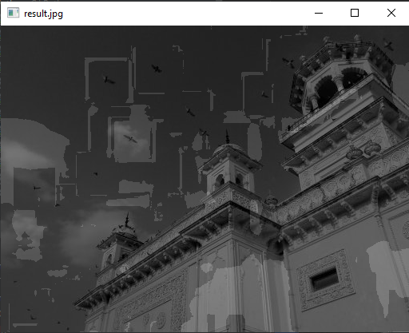

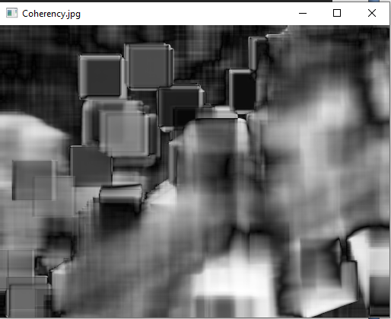

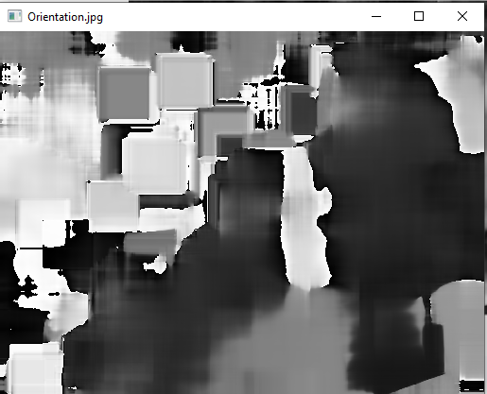

РОБОТА УСПІШНА!

**36) Periodic Noise Removing Filter**

#include <iostream>  
#include "opencv2/highgui.hpp"  
#include <opencv2/imgcodecs.hpp>  
#include <opencv2/imgproc.hpp>  
using namespace cv;  
using namespace std;  
void fftshift(const Mat& inputImg, Mat& outputImg);  
void filter2DFreq(const Mat& inputImg, Mat& outputImg, const Mat& H);  
void synthesizeFilterH(Mat& inputOutput_H, Point center, int radius);  
void calcPSD(const Mat& inputImg, Mat& outputImg, int flag = 0);  
const String keys =  
"{help h usage ? | | print this message }"  
"{@image |period_input.jpg | input image name }"  
;  
int main(int argc, char* argv[])  
{  
 CommandLineParser parser(argc, argv, keys);  
 string strInFileName = parser.get<String>("@image");  
 samples::addSamplesDataSearchSubDirectory("doc/tutorials/imgproc/periodic_noise_removing_filter/images");  
 Mat imgIn = imread(samples::findFile(strInFileName), IMREAD_GRAYSCALE);  
 if (imgIn.empty()) //check whether the image is loaded or not  
 {  
 cout << "ERROR : Image cannot be loaded..!!" << endl;  
 return -1;  
 }  
 imshow("Image corrupted", imgIn);  
 imgIn.convertTo(imgIn, CV_32F);  
 // it needs to process even image only  
 Rect roi = Rect(0, 0, imgIn.cols & -2, imgIn.rows & -2);  
 imgIn = imgIn(roi);  
 // PSD calculation (start)  
 Mat imgPSD;  
 calcPSD(imgIn, imgPSD);  
 fftshift(imgPSD, imgPSD);  
 normalize(imgPSD, imgPSD, 0, 255, NORM_MINMAX);  
 // PSD calculation (stop)  
 //H calculation (start)  
 Mat H = Mat(roi.size(), CV_32F, Scalar(1));  
 const int r = 21;  
 synthesizeFilterH(H, Point(705, 458), r);  
 synthesizeFilterH(H, Point(850, 391), r);  
 synthesizeFilterH(H, Point(993, 325), r);  
 //H calculation (stop)  
 // filtering (start)  
 Mat imgOut;  
 fftshift(H, H);  
 filter2DFreq(imgIn, imgOut, H);  
 // filtering (stop)  
 imgOut.convertTo(imgOut, CV_8U);  
 normalize(imgOut, imgOut, 0, 255, NORM_MINMAX);  
 imwrite("result.jpg", imgOut);  
 imwrite("PSD.jpg", imgPSD);  
 fftshift(H, H);  
 normalize(H, H, 0, 255, NORM_MINMAX);  
 imshow("Debluring", imgOut);  
 imwrite("filter.jpg", H);  
 waitKey(0);  
 return 0;  
}  
void fftshift(const Mat& inputImg, Mat& outputImg)  
{  
 outputImg = inputImg.clone();  
 int cx = outputImg.cols / 2;  
 int cy = outputImg.rows / 2;  
 Mat q0(outputImg, Rect(0, 0, cx, cy));  
 Mat q1(outputImg, Rect(cx, 0, cx, cy));  
 Mat q2(outputImg, Rect(0, cy, cx, cy));  
 Mat q3(outputImg, Rect(cx, cy, cx, cy));  
 Mat tmp;  
 q0.copyTo(tmp);  
 q3.copyTo(q0);  
 tmp.copyTo(q3);  
 q1.copyTo(tmp);  
 q2.copyTo(q1);  
 tmp.copyTo(q2);  
}  
void filter2DFreq(const Mat& inputImg, Mat& outputImg, const Mat& H)  
{  
 Mat planes[2] = { Mat_<float>(inputImg.clone()), Mat::zeros(inputImg.size(), CV_32F) };  
 Mat complexI;  
 merge(planes, 2, complexI);  
 dft(complexI, complexI, DFT_SCALE);  
 Mat planesH[2] = { Mat_<float>(H.clone()), Mat::zeros(H.size(), CV_32F) };  
 Mat complexH;  
 merge(planesH, 2, complexH);  
 Mat complexIH;  
 mulSpectrums(complexI, complexH, complexIH, 0);  
 idft(complexIH, complexIH);  
 split(complexIH, planes);  
 outputImg = planes[0];  
}  
void synthesizeFilterH(Mat& inputOutput_H, Point center, int radius)  
{  
 Point c2 = center, c3 = center, c4 = center;  
 c2.y = inputOutput_H.rows - center.y;  
 c3.x = inputOutput_H.cols - center.x;  
 c4 = Point(c3.x,c2.y);  
 circle(inputOutput_H, center, radius, 0, -1, 8);  
 circle(inputOutput_H, c2, radius, 0, -1, 8);  
 circle(inputOutput_H, c3, radius, 0, -1, 8);  
 circle(inputOutput_H, c4, radius, 0, -1, 8);  
}  
// Function calculates PSD(Power spectrum density) by fft with two flags  
// flag = 0 means to return PSD  
// flag = 1 means to return log(PSD)  
void calcPSD(const Mat& inputImg, Mat& outputImg, int flag)  
{  
 Mat planes[2] = { Mat_<float>(inputImg.clone()), Mat::zeros(inputImg.size(), CV_32F) };  
 Mat complexI;  
 merge(planes, 2, complexI);  
 dft(complexI, complexI);  
 split(complexI, planes); // planes[0] = Re(DFT(I)), planes[1] = Im(DFT(I))  
 planes[0].at<float>(0) = 0;  
 planes[1].at<float>(0) = 0;  
 // compute the PSD = sqrt(Re(DFT(I))^2 + Im(DFT(I))^2)^2  
 Mat imgPSD;  
 magnitude(planes[0], planes[1], imgPSD); //imgPSD = sqrt(Power spectrum density)  
 pow(imgPSD, 2, imgPSD); //it needs ^2 in order to get PSD  
 outputImg = imgPSD;  
 // logPSD = log(1 + PSD)  
 if (flag)  
 {  
 Mat imglogPSD;  
 imglogPSD = imgPSD + Scalar::all(1);  
 log(imglogPSD, imglogPSD);  
 outputImg = imglogPSD;  
 }  
}

На малюнку нижче показано зображення, сильно зіпсоване періодичними шумами різних частот.

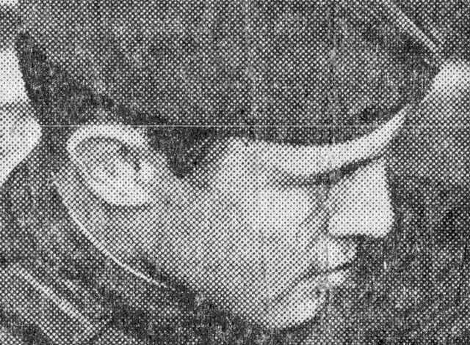

**Зображення пошкоджене періодичним шумом**

Компоненти шуму легко побачити як яскраві точки (спайки) у спектральній щільності потужності, показаній на малюнку нижче.

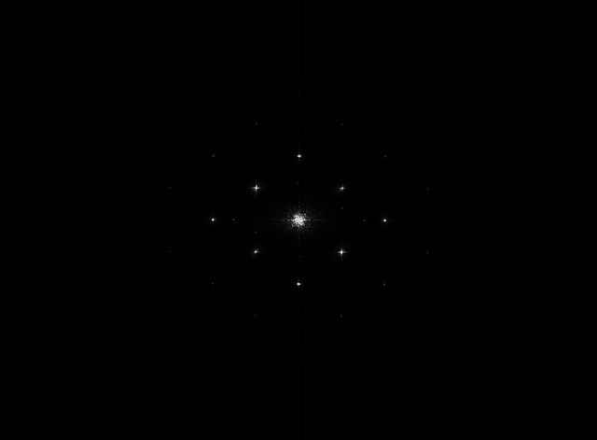

**Щільність спектру потужності, що показує періодичний шум**

На малюнку нижче показано режекторний фільтр із відповідним радіусом, щоб повністю закрити шумові сплески.

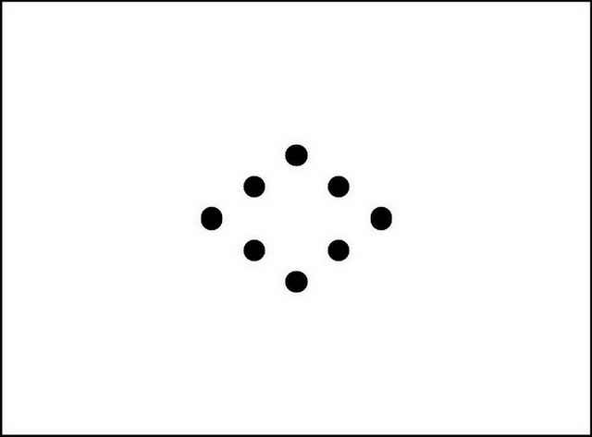

**Виїмковий фільтр**

Результат обробки зображення режекторним фільтром показано нижче.

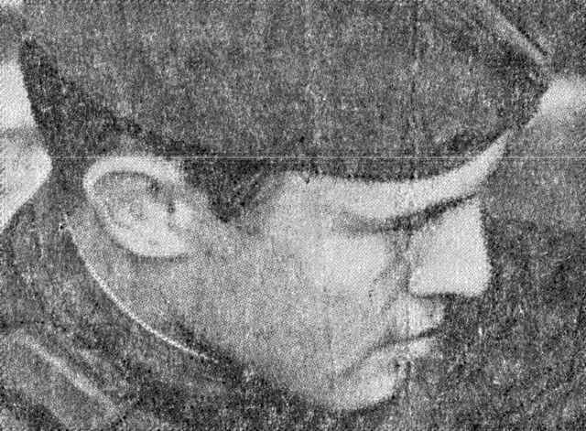

**Результат фільтрації**